SAVEETHA
INSTITUTE OF MEDICAL AND TECHNICAL SCIENCES
CSA15 – CLOUD COMPUTING AND BIG DATA ANALYTICS

ASSIGNMENT 2 – CO2
Analyse, Evaluate and Validate a Virtualization Architecture
for a Multi-Tenant University Private Cloud
CO2: Analyze virtualization architectures to identify performance and security issues in cloud computing environments.

Field | Details | Field | Details
Student Name | B. V. Tharun | Registration Number | 192525155
Department / Section | Not specified in the assignment brief | Academic Year / Semester | 2026
Faculty Name | Dr R. latha | Nature of Assignment | Individual
Duration | 1 Week | Total Marks | 50
Submission Date |  | Evaluation Date

MARK SHEET (Rubric-based evaluation)
Task | Title | Max | Evidence / evaluation focus
1 | Characterise the Virtualization Architectures | 5 | Layered diagrams; trust boundaries; resource virtualization
2 | Identify the Dominant Overhead Source | 2 | Architecture-specific bottleneck and scaling behaviour
3 | Build a Quantitative Performance Model | 6 | CPU, memory, I/O, network and density derivations
4 | Analyse Performance Under Operating Conditions | 4 | Best, typical and worst-case reasoning
5 | Security Threat and Vulnerability Analysis | 3 | Threat model, exposure and CIA impact
6 | Isolation–Performance Trade-off | 3 | Variables, objectives, constraints and decision function
7 | Evaluate Mitigation Strategies | 4 | At least three mitigations with residual risk and cost
8 | Implement and Test | 4 | Reproducible setup, commands and test plan
9 | Record Experimental Performance | 3 | Tables, graphs, repeated measurements and variability
10 | Compare Theory with Experiment | 4 | Prediction-versus-measurement and error analysis
11 | Recommend and Defend Final Architecture | 4 | Performance, security, cost and operational justification
12 | Day-4 Design Challenge | 8 | Big-data workload impact, redesign and evidence-based defence
 | TOTAL | 50

EVIDENCE VERIFICATION CHECKLIST
Tasks | Evidence expected | Status (✓ / P / ✗) | Evaluator note
1 | Three distinct architectures, diagrams and trust boundaries | P | Diagrams and conceptual analysis included; deployment verification required
2–4 | Overhead analysis, quantitative model and operating-condition analysis | P | Analytical assumptions and worked examples documented
5–7 | Threat model, trade-off formulation and mitigations | P | Security analysis and estimated performance costs documented
8–10 | Reproducible tests, measured data, graphs and theory comparison | P | Commands and result templates supplied; actual measurements must be inserted
11–12 | Final recommendation and Day-4 redesign | P | Recommendation is based on analytical model; validate with local experiments

IMPLEMENTATION EVIDENCE CHAIN
Evidence item | Status | Observation
Architecture diagrams | ✓ | Three architecturally distinct approaches illustrated
Analytical performance model | ✓ | CPU, memory, network and density calculations shown
Threat and mitigation analysis | ✓ | Architecture-specific risks and controls evaluated
Test environment | P | Reproducible setup and commands provided; run locally to generate evidence
Experimental measurements | P | No results are represented as measured; record actual repeated runs
Screenshots and logs | P | Insert authentic terminal, dashboard and test screenshots after execution

OVERALL REMARKS
This report presents an analytical design and a reproducible experimental procedure for EduCloud. Numerical outputs identified as model estimates or illustrative calculations are not claimed to be measured results. The experimental tables are provided for recording genuine observations from the test
Environment

Scenario: EduCloud Virtualization Platform
A university runs a private cloud, EduCloud, in its data centre. EduCloud currently consists of:
- 16 physical hosts, each with 64 CPU cores, 512 GB RAM, NVMe SSD storage and 2 × 25 Gbps NICs
- About 400 virtual machines (VMs) running the Student Information System (SIS), the Learning Management System (LMS), the examination portal, and departmental research workloads
- A shared storage backend and a software-defined virtual network
During semester registration week, users report slow response times and failed logins. A recent internal security audit also found that VMs from different departments share the same physical hosts, that some VMs run outdated guest kernels, and that VM images are copied freely between teams.
You are the cloud architect. You must investigate, model, measure and compare virtualization architectures for EduCloud, identify their performance bottlenecks and security weaknesses, and recommend a design that remains practical as the platform grows.
Design Challenge:
The university now plans to host external research collaborators' big-data workloads (Spark/Hadoop clusters) on the same infrastructure as the SIS. Reevaluate your design under these new multi-tenant conditions.

TASK 1: Characterise the Virtualization Architectures (5 Marks)
Select at least three meaningfully different virtualization approaches from the following, or justify others:
- Type-1 (bare-metal) hypervisor with full virtualization
- Type-2 (hosted) hypervisor
- Hardware-assisted virtualization vs. paravirtualization
- OS-level virtualization (containers)
- Lightweight/micro-VM or sandboxed container runtimes
Two configurations of the same hypervisor will not count as different approaches. Your selection must include at least one VM-based and at least one container-based approach.
For each approach, provide:
- A layered architecture diagram showing the hardware, host OS or hypervisor, guest OS, runtime and application
- The trust boundaries and the component that enforces isolation
- How CPU, memory, storage and network are virtualized
- A brief justification for why this approach is relevant to EduCloud
Evidence expected: Three architecturally distinct approaches with labelled diagrams, resource-virtualization mechanisms, trust boundaries, and justification of selection.

TASK 2: Identify the Dominant Overhead Source (2 Marks)
For each approach, identify the primary source of performance overhead that predominantly limits its performance (for example VM exits/traps, nested or extended page-table walks, virtual I/O emulation, virtual switch processing, or system-call interception).
Discuss:
- What the overhead source is
- Where in the architecture it occurs
- Why it is appropriate as the focus of performance analysis
- How its frequency or cost changes as the number of co-located VMs/containers or the I/O rate increases
Do not simply name a mechanism. Relate it to the behaviour of the architecture.
Evidence expected: A justified dominant-overhead identification for each approach, linked to its resource-virtualization path.

TASK 3: Build a Quantitative Performance Model (6 Marks)
Using the following host parameters, develop an analytical performance model for each approach.
Parameter | Value
Physical cores per host | 64
vCPU:pCPU overcommit ratio | 1:1, 2:1, 4:1, 8:1
RAM per host | 512 GB
Average VM memory demand | 8 GB
Cost of one VM exit (assume) | 1.5 µs
Native system-call cost (assume) | 0.2 µs
Network line rate | 25 Gbps

State and justify any additional assumptions. Derive expressions for:
- CPU: effective per-VM CPU capacity as a function of overcommit ratio and virtualization overhead (including steal time)
- Memory: the maximum number of VMs per host before ballooning, swapping or page-sharing becomes necessary
- I/O and network: effective throughput as a function of the number of VMs sharing the physical device
- Density: the number of VMs/containers a host can support while meeting a stated service-level target (for example, ≤ 10% performance degradation)
Show the mathematical reasoning. Merely quoting overhead percentages from the literature will not receive full credit.
Evidence expected: A clear mathematical derivation for each approach, with stated assumptions, parameter values and worked numerical examples.

TASK 4: Analyse Performance Under Different Operating Conditions (4 Marks)
Analyse how each approach behaves under three conditions:
- Best case: what workload and placement conditions minimise overhead?
- Typical case: for example, registration-week mixed web and database load
- Worst case: for example, noisy-neighbour interference, memory overcommit with swapping, live migration during peak load, or I/O storms
For each, explain what happens inside the virtualization layer, why the overhead changes, and how latency and throughput are affected. A table of numbers alone will not be accepted.
Evidence expected: A justified condition-based analysis supported by your Task 3 model.

TASK 5: Security Threat and Vulnerability Analysis (3 Marks)
Construct a threat model for each approach. Discuss:
- The attack surface (hypervisor, device emulation, shared kernel, management plane, VM images and snapshots, virtual network)
- At least four distinct threat categories, such as VM escape, cross-VM side-channel attacks, hypervisor or container-runtime vulnerabilities, VM sprawl and unpatched guests, image tampering, insecure live migration, and virtual-network sniffing or spoofing
- For each threat, which approach is more or less exposed and why, referring to its architecture and trust boundaries
- The likely impact on the confidentiality, integrity and availability of student records
Evidence expected: A structured threat model mapped to architectural features, with a justified comparison across approaches.

TASK 6: Formulate the Isolation–Performance Trade-off (3 Marks)
Formalise the trade-off between isolation strength and performance/density for EduCloud.
Clearly identify:
- The decision variables (for example, approach chosen, VMs per host, dedicated vs. shared hosts, SMT on/off)
- The objective(s), such as maximising density or minimising cost
- The constraints (for example, performance degradation limit, isolation requirement for SIS, available hosts)
- How these components combine into a cost or decision function
The formulation must follow from your own analysis in Tasks 3 and 5, not from a generic template.
Evidence expected: A clearly defined trade-off model with identified variables, objective and constraints.

TASK 7: Evaluate Mitigation Strategies (4 Marks)
Propose at least three mitigations for the vulnerabilities identified in Task 5. Examples include disabling SMT, kernel page-table isolation, dedicated hosts for sensitive tenants, secure or sandboxed container runtimes, hardware memory encryption, image signing, and micro-segmentation.
For each mitigation, discuss:
- Why it is applicable to the threat
- What residual risk remains
- The performance or density cost, estimated using your Task 3 model
- Whether the trade-off is acceptable for the SIS
Evidence expected: Mitigations evaluated analytically, with their security benefit and quantified performance cost.

TASK 8: Implement and Test (4 Marks)
Build a test environment and experimentally test all selected approaches.
- Platforms: use any open-source stack, for example KVM/QEMU, Xen or VirtualBox, Docker/Podman, and Kata Containers or gVisor. Nested virtualization on a laptop is acceptable if documented.
- Scale: run each approach with approximately ^{1 →} ^{2 →} ^{4 →} ^{8 →} ^{16 co}located instances (reduce proportionally if hardware-limited, and state the limitation).
- Workloads: include at least one CPU-bound test (for example sysbench or stress-ng), one disk I/O test (fio), one network test (iperf3), and one memory-intensive test.
- Interference test: run at least one noisy-neighbour experiment.
- Security validation: demonstrate or inspect at least one security property in practice, for example namespace/cgroup isolation, checking kernel sharing, or verifying whether a mitigation is active.
Ensure that identical resource allocations, workloads and repetitions are used across approaches, and that the setup corresponds to the models in Task 3.
Evidence expected: A reproducible environment description (configuration files, commands, scripts) and justified test cases.

TASK 9: Record Experimental Performance (3 Marks)
Collect and present data such as:
- Throughput, latency (mean and 95th percentile), CPU steal time, context switches and VM exits where observable
- Instance start-up time and memory footprint per instance
- Performance degradation versus a bare-metal baseline
- Results with and without at least one security mitigation
Present at least one table and two graphs (for example, throughput versus number of instances, and latency under interference). Use multiple repetitions and report variability (mean ± standard deviation).
Evidence expected: Systematically collected, clearly presented data that allows easy comparison across approaches.

TASK 10: Compare Theory with Experiment (4 Marks)
Compare your Task 3 and Task 4 predictions with Task 9 measurements.
Discuss:
- Whether the observed degradation trends agree with your model
- Which approach scales better as co-located instances increase
- Quantitative differences between predicted and measured values, and plausible causes (for example caching effects, hypervisor scheduler behaviour, nested virtualization, laptop hardware, or unmodelled I/O paths)
- Whether any measured result changes your security conclusions from Task 5
Interpret the results; do not simply reproduce tables.
Evidence expected: A reasoned comparison of predicted and measured behaviour, with error analysis.

TASK 11: Recommend and Defend the Final Architecture (4 Marks)
Recommend the virtualization architecture (or hybrid) for EduCloud's SIS and LMS workloads.
Discuss:
- Which approach you recommend and why it is more appropriate than the alternatives
- Its modelled and experimentally observed performance
- Its security posture and residual risks
- Operational costs such as patching, image management, migration and monitoring
- Limitations and trade-offs
- Whether it remains practical as EduCloud grows from 400 to several thousand instances
Your recommendation must rest on your own analysis and experiments. Choosing "the most secure" or "the fastest" option alone is not sufficient.
Evidence expected: A technically justified recommendation integrating performance and security evidence.

DAY-4 DESIGN CHALLENGE
TASK 12: Re-evaluate and Adapt the Design (8 Marks)

Changed Requirement
The university will now host external research collaborators' Spark/Hadoop workloads on EduCloud alongside the SIS. The new conditions are:
- Big-data jobs are I/O- and network-intensive and run for hours
- Registration-week peak load is about 3× normal
- Hosts are sometimes patched using live migration of running VMs
- A data-protection regulation now requires demonstrable isolation of student records from external tenants
You may RETAIN → MODIFY → or REDESIGN your original solution.

A. Impact Analysis (2 Marks)
Discuss what has changed, which original assumptions (trusted tenants, workload mix, I/O profile) no longer hold, and how mixing batch big-data workloads with latency-sensitive SIS workloads changes both the performance and the threat model.

B. Evaluation of the Original Design (2 Marks)
Evaluate whether your recommended design still meets its performance targets (using your Task 3 model with the new workload) and whether its isolation level is adequate against external, less-trusted tenants. Consider whether another architecture could do better overall.

C. Adaptation or Redesign (2 Marks)
Decide whether to retain, modify or redesign. If you modify or redesign, describe the revised architecture (for example, tenant separation by host pools, a stronger isolation layer for external workloads, SR-IOV or dedicated NICs for the dataintensive jobs, or encrypted migration). Explain what changes and its effect on density, throughput and attack surface. If you retain, justify why no change is required.

D. Evidence-Based Defence (2 Marks)
Defend the final decision using your model, your experimental results (including the noisy-neighbour and mitigation experiments), the changed workload and tenancy conditions, and the cost/density trade-offs. The decision must follow logically from the analysis.

MARK DISTRIBUTION
Task | Marks
Task 1 – Architecture Characterisation | 5
Task 2 – Dominant Overhead Identification | 2
Task 3 – Quantitative Performance Model | 6
Task 4 – Performance Under Operating Conditions | 4
Task 5 – Security Threat and Vulnerability Analysis | 3
Task 6 – Isolation–Performance Trade-off Formulation | 3
Task 7 – Mitigation Evaluation | 4

Task 8 – Implementation and Testing | 4
Task 9 – Experimental Performance | 3
Task 10 – Theory vs. Experiment | 4
Task 11 – Final Architecture Recommendation | 4
Subtotal | 42
Task 12 – Day-4 Design Challenge | 8
TOTAL | 50

TASK 1: Characterise the Virtualization Architectures
1. Introduction
Virtualization is a technology that allows multiple isolated computing environments to operate using the resources of a single physical machine. It enables efficient utilization of CPU, memory, storage and network resources.
For the EduCloud platform, three architecturally different virtualization approaches are selected:
- Type-1 hypervisor with full virtualization (VM-based).
- Type-2 hypervisor with hosted virtualization (VM-based).
- OS-level virtualization using containers (container-based).
These approaches are selected because they provide different levels of isolation, performance, resource utilization and management flexibility.
2. Approach 1: Type-1 Hypervisor with Full Virtualization
2.1 Definition
A Type-1 hypervisor, also called a bare-metal hypervisor, runs directly on the physical hardware without requiring a separate general-purpose host operating system.
It creates and manages multiple virtual machines, each having its own guest operating system and applications.
Examples: VMware ESXi, Microsoft Hyper-V and KVM-based virtualization.
2.2 Layered Architecture Diagram
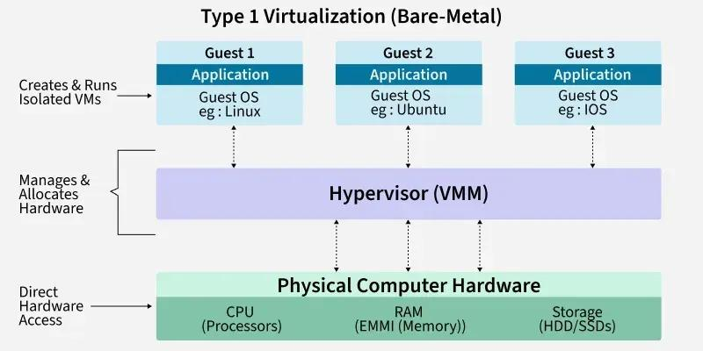
Architecture layers:
- Physical hardware – CPU, RAM, SSD and network interface cards.
- Hypervisor – Manages hardware resources and creates virtual machines.
- Virtual hardware – Provides virtual CPU, memory, disk and network interfaces.
- Guest operating system – Runs independently inside each VM.
- Application layer – Runs university applications such as SIS and LMS.
2.3 Trust Boundaries and Isolation
- The physical hardware and hypervisor form the trusted foundation.
- Each VM operates inside an isolated virtual machine boundary.
- The hypervisor enforces isolation between different VMs.
- Guest operating systems are not automatically trusted by other VMs.
- Hardware virtualization extensions help protect and manage execution.
Isolation enforcement: Hypervisor using hardware-assisted virtualization such as Intel VT-x or AMD-V.
2.4 Resource Virtualization Mechanisms
Resource | Virtualization mechanism
CPU | vCPUs are scheduled onto physical CPU cores by the hypervisor.
Memory | Guest memory is mapped to physical memory using mechanisms such as EPT or NPT.
Storage | Virtual disks are provided through files, logical volumes or storage devices.
Network | Virtual NICs and virtual switches connect VMs to virtual networks.
2.5 Relevance to EduCloud
Type-1 virtualization is highly suitable for EduCloud because the university operates approximately 400 VMs across 16 physical hosts.
It provides:
- Strong isolation between university departments.
- Efficient hardware resource management.
- Better performance for production applications.
- Support for critical SIS, LMS and examination systems.
- Centralized VM management and monitoring.
Justification: This is the recommended primary virtualization architecture for EduCloud because university applications require reliability, security and predictable performance.
3. Approach 2: Type-2 Hypervisor with Hosted Virtualization
3.1 Definition
A Type-2 hypervisor, also known as a hosted hypervisor, runs as an application on top of an existing host operating system.
It uses the host OS to access physical hardware resources and creates multiple virtual machines with independent guest operating systems.
Examples: Oracle VirtualBox and VMware Workstation.
3.2 Layered Architecture Diagram
Application Layer
Browser, Testing Software, Development Tools
Guest Operating System
Windows / Linux inside VM
Type-2 Hypervisor
VirtualBox / VMware Workstation
Host Operating System
Windows / Linux
Physical Hardware
CPU, RAM, SSD and Network Interface
Figure 2: Type-2 hosted virtualization architecture
3.3 Trust Boundaries and Isolation
- The physical hardware and host operating system form the trusted foundation.
- The hosted hypervisor creates separate VM environments.
- Each VM has an independent guest operating system.
- The hypervisor provides isolation between guest environments.
- The host OS remains an additional security dependency.
Isolation enforcement: Hosted hypervisor, supported by the host operating system and hardware virtualization features.

3.4 Resource Virtualization Mechanisms
Resource | Virtualization mechanism
CPU | Virtual CPUs are scheduled through the hosted hypervisor and host OS.
Memory | Guest memory is mapped to host physical memory.
Storage | Virtual disk files are stored on the host filesystem.
Network | Virtual network adapters connect through host networking and virtual switches.
3.5 Relevance to EduCloud
Type-2 virtualization is useful for:
- Student programming laboratories.
- Software testing environments.
- Application development.
- Operating system experiments.
- Temporary training environments.
Justification: It is useful for non-critical university activities, but it is not recommended for production SIS and LMS workloads because of additional host OS overhead and a larger trusted software base.
4. Approach 3: OS-Level Virtualization Using Containers
4.1 Definition
OS-level virtualization is a technology that creates multiple isolated application environments called containers on a single host operating system.
Unlike virtual machines, containers do not require separate guest operating systems. They share the host operating system kernel while maintaining isolated processes, filesystems and network environments.
Examples: Docker, Podman and containerd.
4.2 Layered Architecture Diagram
Container Applications
SIS API | Spark Worker | Research Applications
Container Runtime
Docker / containerd / Podman
Host OS Kernel
Namespaces, cgroups, capabilities and security controls
Physical Hardware
CPU, RAM, SSD and Network Interface
Figure 3: OS-level container virtualization architecture
Note: Each container also includes its application dependencies and user-space libraries. It does not have a separate guest kernel.
4.3 Trust Boundaries and Isolation
- All containers share the same host OS kernel.
- Each container has an isolated process and network environment.
- Linux namespaces isolate process IDs, networking, mounts and users.
- Control groups (cgroups) control CPU, memory and other resource consumption.
- Seccomp and Linux capabilities restrict potentially dangerous operations.
Isolation enforcement: Host OS kernel using namespaces, cgroups and additional security mechanisms.
Trust boundary: The shared host kernel is a critical trust boundary. A kernel vulnerability may affect multiple containers.
4.4 Resource Virtualization Mechanisms
Resource | Virtualization mechanism
CPU | cgroups control CPU allocation and usage.
Memory | Memory limits and accounting are managed through cgroups.
Storage | Container images, writable layers and volume mounts provide isolated storage.
Network | Network namespaces, virtual Ethernet interfaces and virtual bridges provide network isolation.
4.5 Relevance to EduCloud
Containers are highly suitable for:
- Spark and Hadoop services.
- Microservices-based applications.
- Research applications.
- Development and testing environments.
- Scalable web applications.
Justification: Containers provide lightweight execution, fast startup and efficient resource utilization. They are particularly useful for external research workloads that require multiple distributed processing services. However, strict kernel and tenant isolation controls are necessary.
5. Comparison of the Three Virtualization Approaches
Characteristic | Type-1 | Type-2 | Containers
Architecture | Bare-metal | Hosted | OS-level
Guest OS | Separate per VM | Separate per VM | Shared host kernel
Performance | High | Lower due to host OS overhead | High efficiency
Startup time | VM boot time | VM boot time | Usually seconds or less
CPU isolation | Hypervisor | Hypervisor | cgroups and scheduler
Memory isolation | Hypervisor | Hypervisor | Kernel memory controls
Storage isolation | Virtual disks | Host-based virtual disks | Filesystems and volumes
Network isolation | Virtual switches | Host networking | Network namespaces
Isolation strength | Strong | Depends on host and hypervisor | Shared-kernel dependent
Main use | Production cloud | Development/testing | Microservices and big data

6. Overall Trust Boundary Comparison
Architecture | Main trusted component | Isolation enforcement
Type-1 | Hypervisor and hardware | Hypervisor and hardware virtualization
Type-2 | Host OS and hypervisor | Hosted hypervisor
Containers | Host OS kernel | Namespaces, cgroups and kernel security controls

7. Final Selection and Justification for EduCloud
The three approaches have different strengths and limitations.
For EduCloud, the recommended design is a combination of Type-1 virtualization and containerization.
- Type-1 hypervisor: Used for critical university services such as SIS, LMS and examination systems because it provides strong VM isolation and efficient resource management.
- Type-2 hypervisor: Used in student laboratories, development and testing environments.
- Containers: Used for Spark, Hadoop and scalable research applications because they provide lightweight execution and efficient resource utilization.
External research collaborators should be placed in separate tenant environments with CPU, memory, storage and network limits. For stronger isolation, containers for external tenants should run inside dedicated VMs rather than directly on the university's shared host kernel.
Conclusion: Type-1 virtualization provides the main foundation for EduCloud, while containers improve scalability and resource efficiency. Type-2 virtualization supports development and testing. Combining these approaches helps EduCloud achieve better performance, security, resource utilization and multi-tenant scalability.

TASK 2: Identify the Dominant Overhead Source
1. Introduction
Virtualization overhead is the additional processing time and resource consumption introduced by the virtualization layer when applications access physical hardware resources.
In EduCloud, approximately 400 VMs operate across 16 physical hosts. During semester registration, multiple users access SIS, LMS and examination services simultaneously. The addition of external Spark and Hadoop workloads increases CPU, memory, storage and network demand.
Therefore, identifying the dominant overhead source in each virtualization architecture is important for improving application response time, reducing resource contention and maintaining performance.
The three approaches considered are:
- Type-1 hypervisor with full virtualization.
- Type-2 hosted hypervisor.
- OS-level virtualization using containers.
2. Approach 1: Type-1 Hypervisor – Dominant Overhead
2.1 Primary Overhead: VM Exits and Virtual I/O Processing
In Type-1 virtualization, the hypervisor directly manages physical hardware and multiple guest VMs.
The main performance overhead occurs when a guest VM performs operations that require hypervisor intervention, particularly VM exits and virtual I/O processing.
What is VM Exit?
A VM exit occurs when a running guest VM encounters an operation or event that requires control to transfer from the guest execution environment to the hypervisor.
Examples include:
- Certain privileged operations.
- Interrupt handling.
- Access to emulated devices.
- Some memory-management operations.
2.2 Location of Overhead
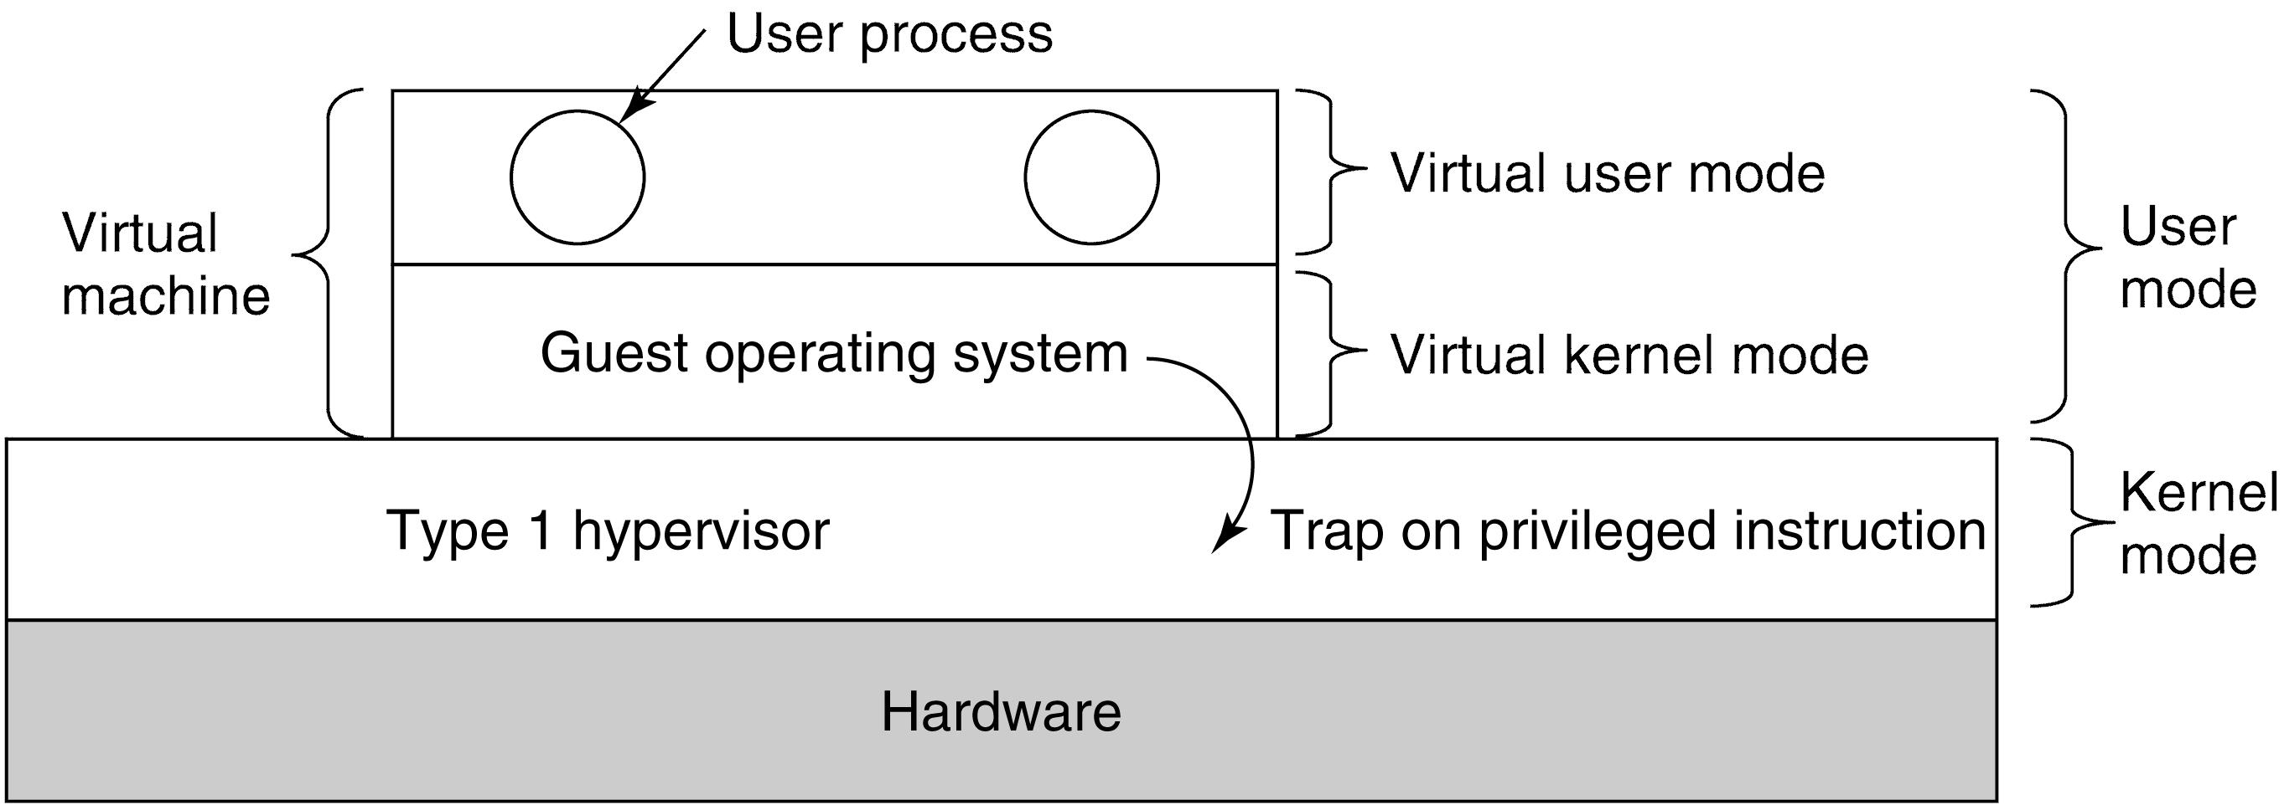The overhead occurs between the guest operating system and the hypervisor during VM execution and hardware access.
2.3 Flowchart of VM Exit Overhead
A 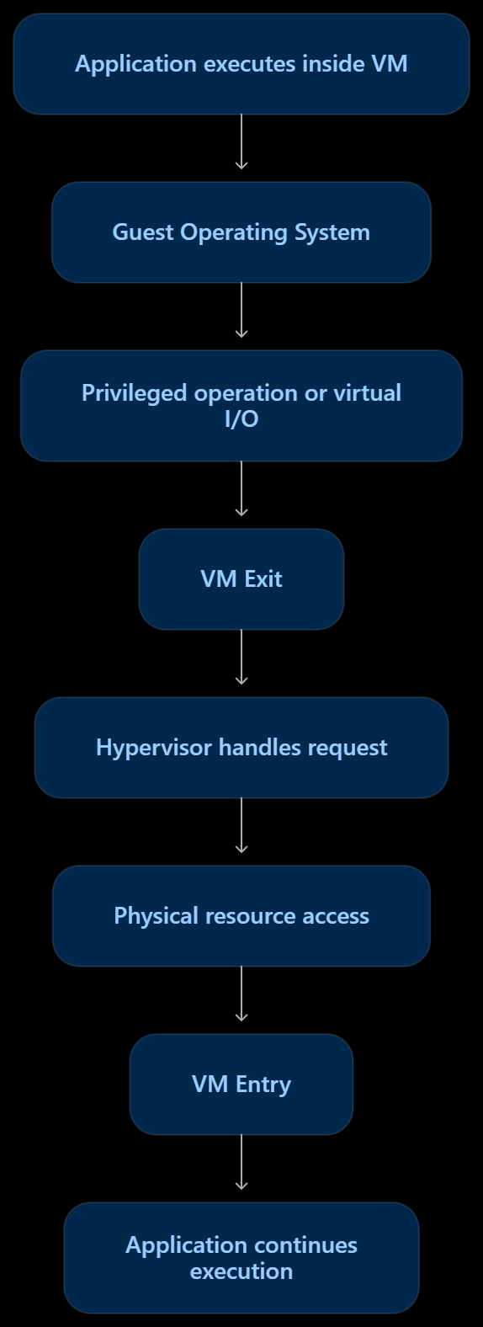

2.4 Why It Is Important for Performance Analysis
When many VMs operate on the same physical host, the hypervisor must handle more virtual machine events and I/O requests.
For example, during semester registration, multiple SIS and LMS VMs may generate simultaneous database and network requests.
This can increase VM exits, virtual device processing and hypervisor scheduling activity, causing additional latency.
2.5 Effect of Increasing VM Count and I/O Rate
Workload condition | Performance effect
Low VM count | Fewer competing requests and lower overhead
High VM count | More scheduling and virtualization activity
High I/O rate | Increased virtual device processing and possible VM exits
Heavy memory activity | More address translation and possible page-table walk overhead
Spark/Hadoop workload | Increased CPU, memory and storage contention
Analysis: As the number of co-located VMs and their I/O rates increase, the total cost of hypervisor intervention and virtual device processing can increase. Consequently, application response time may become slower.
EduCloud relevance: VM exits and virtual I/O processing should be measured alongside CPU scheduling and memory translation to identify whether the hypervisor is becoming a performance bottleneck.
3. Approach 2: Type-2 Hypervisor – Dominant Overhead
3.1 Primary Overhead: Host OS Scheduling and Virtual I/O Emulation
In Type-2 virtualization, the hypervisor runs as an application on top of a host operating system.
The primary overhead is caused by the additional host OS scheduling and virtual I/O processing required when guest VMs access physical hardware.
What is the overhead?
When a guest VM requests storage or network access, the request passes through the hosted hypervisor and host operating system before reaching the physical device.

This additional processing introduces:
- Extra context switches.
- Host OS scheduling delays.
- Virtual device emulation overhead.
- Additional data copying and I/O processing.
3.2 Location of Overhead
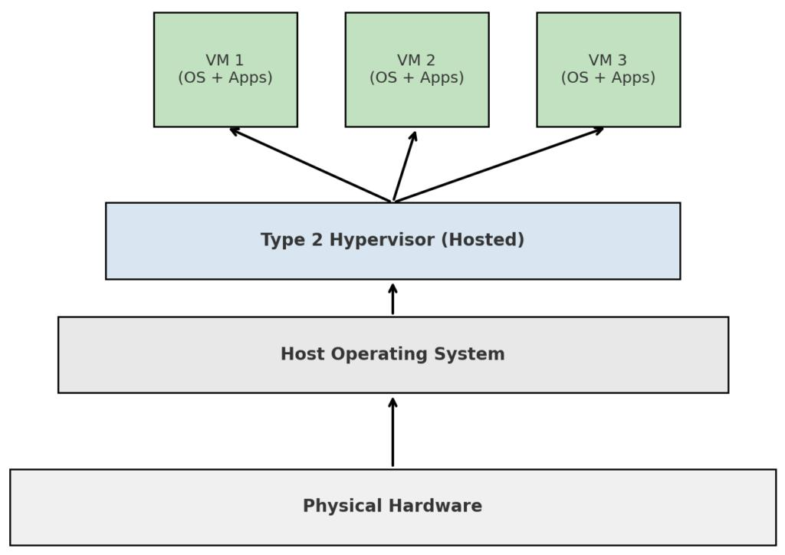The overhead occurs mainly between the hosted hypervisor, host OS and physical hardware.
3.3 Flowchart of Type-2 I/O Overhead
#
3.4 Why It Is Important for Performance Analysis
Unlike Type-1 virtualization, Type-2 virtualization introduces an additional host operating system layer.
When multiple VMs generate simultaneous storage and network requests, the host OS must schedule and process these operations along with its own activities.
For example, if several departmental VMs access a shared storage system simultaneously, the host OS and hosted hypervisor may introduce additional I/O latency.
3.5 Effect of Increasing VM Count and I/O Rate
Workload condition | Performance effect
Low VM count | Host OS can process requests efficiently
High VM count | Increased scheduling and context switching
High storage I/O | More host filesystem and virtual disk processing
High network traffic | Increased packet processing and virtual switching
Heavy CPU workload | Competition between guest VMs and host OS
Analysis: As the number of VMs and I/O requests increases, the host OS experiences greater scheduling and resource contention. This can increase response time and reduce overall throughput.
EduCloud relevance: Type-2 overhead is important when comparing hosted virtualization against bare-metal virtualization. It helps explain why Type-2 hypervisors are less suitable for critical production services such as SIS and examination systems.
4. Approach 3: OS-Level Virtualization – Dominant Overhead
4.1 Primary Overhead: Virtual Network and Storage Processing
Containers share the host operating system kernel. They do not require separate guest operating systems.
In EduCloud, the dominant overhead for I/O-intensive container workloads is often caused by virtual network processing and container storage operations.
What is the overhead?
Container networking and storage introduce additional processing when application data travels through virtual interfaces, bridges, overlay networks or container filesystem layers.
Examples include:
- Virtual Ethernet interface processing.
- Bridge and virtual switch packet forwarding.
- Network address translation (NAT).
- Overlay network encapsulation.
- Container filesystem and storage-layer processing.
4.2 Location of Overhead
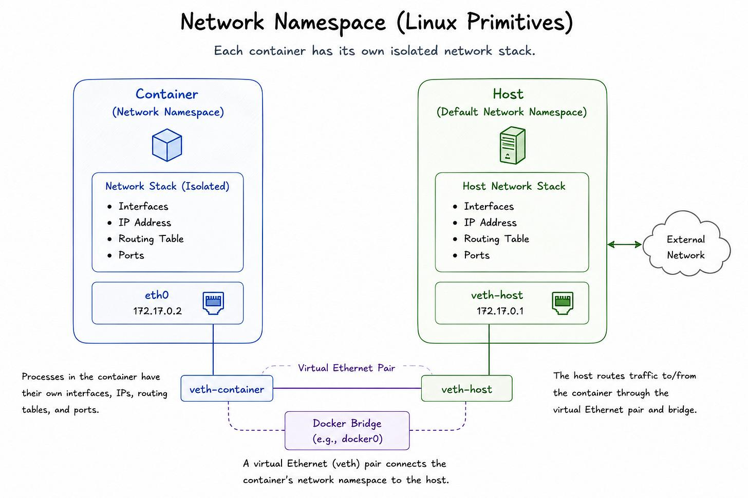The overhead occurs mainly inside the host OS kernel, container networking stack and container storage layers.
4.3 Flowchart of Container I/O Overhead
iner Receives DataApplication Continues
4.4 Why It Is Important for Performance Analysis
Containers are lightweight, but sharing the host kernel does not eliminate all virtualization overhead.
For example, an external research collaborator may run Apache Spark workers inside multiple containers. These workers continuously exchange large datasets across the network.
If many containers communicate simultaneously, virtual network processing, packet forwarding and storage access can increase CPU consumption and network latency.
For Spark and Hadoop, storage throughput and network communication are especially important because distributed processing requires frequent data transfers between worker nodes.

4.5 Effect of Increasing Container Count and I/O Rate
Workload condition | Performance effect
Low container count | Low networking and storage overhead
High container count | More resource scheduling and network processing
High network traffic | Increased virtual switching and packet forwarding
High storage I/O | More filesystem and volume processing
Large Spark workloads | Increased network and storage contention
Analysis: As the number of containers and communication requests increases, the host kernel processes more packets and storage operations. This may increase CPU usage, I/O latency and network congestion.
EduCloud relevance: Container network and storage processing must be measured because external Spark/Hadoop workloads can generate significant distributed data traffic and compete with university applications.
5. Comparative Analysis of Dominant Overhead Sources
The following table summarizes the main performance overheads across the three virtualization approaches.
Parameter | Type-1 Hypervisor | Type-2 Hypervisor | Containers
Dominant overhead | VM exits and virtual I/O | Host OS scheduling and virtual I/O | Virtual network and storage processing
Overhead location | Hypervisor layer | Hypervisor and host OS | Host OS kernel
Main cause | Guest-to-hypervisor transitions | Additional OS processing | Packet forwarding and filesystem layers
CPU impact | Hypervisor processing | Context switching | Kernel packet processing
Memory impact | Address translation | Host and guest memory management | Shared kernel memory management
I/O impact | Virtual device processing | Additional I/O path | Virtual interfaces and storage layers
Scaling effect | More VM events and contention | More host scheduling and I/O contention | More packet and storage processing
6. Relationship Between Workload and Performance Overhead
7. Performance Measurement Parameters
To identify the actual dominant overhead in EduCloud, the following parameters should be measured.
Metric | Measurement purpose | Suggested tool
VM exits per second | Measures hypervisor intervention | Hypervisor performance counters
CPU context switches | Measures scheduling overhead | Linux perf
CPU utilization | Measures processor consumption | Prometheus
Memory page faults | Identifies memory-management activity | Linux perf
Disk latency | Measures storage delays | fio
Network throughput | Measures network performance | iperf3
Packet processing | Identifies network overhead | Linux perf / eBPF
Application response time | Measures user experience | Apache JMeter
7.1 Proposed Experimental Procedure
- Run the three virtualization approaches under controlled workloads.
- Start with a small number of VMs or containers.
- Gradually increase the number of co-located workloads.
- Generate CPU-intensive and I/O-intensive operations.
- Measure VM exits, scheduling activity, storage latency and network throughput.
- Record application response time.
- Compare the results to identify the dominant bottleneck.

8. Final Conclusion
The dominant performance overhead differs according to the virtualization architecture.
- Type-1 hypervisor: VM exits and virtual I/O processing introduce additional hypervisor intervention during guest operations.
- Type-2 hypervisor: Host OS scheduling and virtual I/O introduce additional processing between guest VMs and physical hardware.
- Containers: Virtual networking and storage processing introduce overhead when multiple containers exchange large amounts of data.
For EduCloud, these overheads become more important when external Spark and Hadoop workloads operate alongside critical university applications.
Therefore, monitoring VM exits, host scheduling, storage latency and virtual network processing is essential for identifying bottlenecks and designing a scalable virtualization platform.
Overall recommendation: Use Type-1 virtualization for critical university workloads and isolated container environments for research workloads, with resource limits and continuous performance monitoring.
TASK 3: Build a Quantitative Performance Model
1. Introduction
A quantitative performance model is a mathematical representation used to estimate how efficiently a virtualization platform uses physical computing resources.
In EduCloud, each physical host contains 64 CPU cores, 512 GB RAM and a 25 Gbps network interface. Multiple VMs and containers share these resources.
The purpose of this task is to develop mathematical models for three virtualization approaches:
- Type-1 hypervisor with full virtualization.
- Type-2 hosted hypervisor.
- OS-level virtualization using containers.
The models evaluate CPU capacity, memory capacity, I/O and network throughput, and maximum workload density while maintaining a service-level target of no more than 10% performance degradation.
2. Given Host Parameters
2.1 System Configuration
Parameter | Symbol | Given value
Physical CPU cores | \(C\) | 64
vCPU:pCPU overcommit ratio | \(R\) | 1:1, 2:1, 4:1, 8:1
Physical RAM | \(M\) | 512 GB
Average VM memory demand | \(m\) | 8 GB
Cost of one VM exit | \(t_e\) | 1.5 µs
Native system-call cost | \(t_s\) | 0.2 µs
Network line rate | \(B\) | 25 Gbps
Maximum acceptable degradation | \(D\) | 10%
2.2 Additional Assumptions
The following assumptions are used because some workload parameters are not provided in the question.
Parameter | Assumed value | Reason
Host memory reserved for OS/hypervisor | 32 GB | Host operating requirements
Available memory for workloads | 480 GB | 512 − 32 GB
VM allocation | 1 vCPU per VM | Simplifies comparison
Container memory demand | 8 GB | Same workload demand for comparison
Container runtime overhead | 0.05 µs per system call | Illustrative modelling assumption
Type-1 VM exits | 10,000 exits/sec per VM | Illustrative workload
Type-2 VM exits | 10,000 exits/sec per VM | Illustrative workload
Guest system calls | 100,000 calls/sec per workload | Illustrative workload
Network sharing | Equal sharing | Simplifies throughput estimation
CPU workload | Fully utilized | Evaluates worst-case contention
Note: The assumed event rates and container overhead are modelling inputs, not measured EduCloud results. Actual values must be obtained through performance monitoring.
3. CPU Performance Model
CPU performance measures how much physical processing capacity is available to each VM or container after virtualization overhead and CPU contention.
3.1 Basic CPU Capacity Formula
The total available virtual CPU capacity is:
$$V=C×R$$

Where:
- C = Physical CPU cores.
- R= CPU overcommit ratio.
- V = Total allocated virtual CPUs.
For EduCloud:
C=64
Therefore:
Overcommit ratio | Total available vCPUs
1:1 | \(64\times1=64\)
2:1 | \(64\times2=128\)
4:1 | \(64\times4=256\)
8:1 | \(64\times8=512\)
3.2 Effective CPU Capacity per VM
The effective CPU capacity depends on the overcommit ratio, virtualization overhead and CPU steal time.
The formula is:

The formula is:

TASK 4: Analyse Performance Under Different Operating Conditions
1. Introduction
Virtualization performance changes depending on workload intensity, resource allocation, VM placement, memory utilization and network traffic.
In EduCloud, approximately 400 VMs share 16 physical hosts. During semester registration, SIS, LMS and examination applications experience high user demand. The introduction of external Spark and Hadoop workloads creates additional CPU, memory, storage and network requirements.
This task analyses the three virtualization approaches under three operating conditions:
- Best-case condition.
- Typical-case condition.
- Worst-case condition.
The analysis uses the CPU, memory and network models developed in Task 3.
2. Best-Case Operating Condition
2.1 Type-1 Hypervisor
Workload condition:
- Small number of active VMs.
- CPU overcommit ratio of 1:1.
- Sufficient available RAM.
- Low storage and network traffic.
- Critical VMs placed on separate physical hosts where possible.
What happens inside the virtualization layer?
The Type-1 hypervisor directly controls physical hardware. When a VM executes normal application instructions, the processor executes them using hardware virtualization support.
Because the number of VMs is low, the hypervisor performs fewer scheduling operations and experiences less contention.
Memory translation through extended page tables (EPT/NPT) also operates without significant memory pressure.
Performance impact:
- Low VM exit frequency.
- Less CPU steal time.
- Low storage latency.
- High network throughput.
- Faster SIS and LMS response times.
EduCloud example: During normal university working days, the SIS database and web server operate with sufficient CPU and memory resources.
2.2 Type-2 Hypervisor
Workload condition:
- Few guest VMs.
- Low host OS activity.
- Minimal virtual disk operations.
- Sufficient physical memory.
What happens inside the virtualization layer?
The guest VM sends requests through the hosted hypervisor. The host operating system schedules these requests and provides access to physical hardware.
When the host OS has sufficient resources, additional scheduling and context-switching overhead remains relatively low.
Performance impact:
- Fewer host OS scheduling delays.
- Reduced virtual I/O processing.
- Low guest response time.
- Stable VM performance.
EduCloud example: Students use a small number of VirtualBox VMs for programming and software testing.
2.3 Container Virtualization
Workload condition:
- Small number of containers.
- Low network communication.
- Sufficient CPU and RAM.
- Minimal filesystem activity.
What happens inside the virtualization layer?
Containers share the host OS kernel. Namespaces provide process and network isolation, while cgroups control CPU and memory consumption.
When the number of containers is low, kernel scheduling and virtual network processing require fewer resources.
Performance impact:
- Low kernel processing overhead.
- Fast application startup.
- Reduced network processing delays.
- High resource utilization efficiency.
EduCloud example: A small Spark development environment runs a few containers without competing with university services.
2.4 Best-Case Architecture Diagram
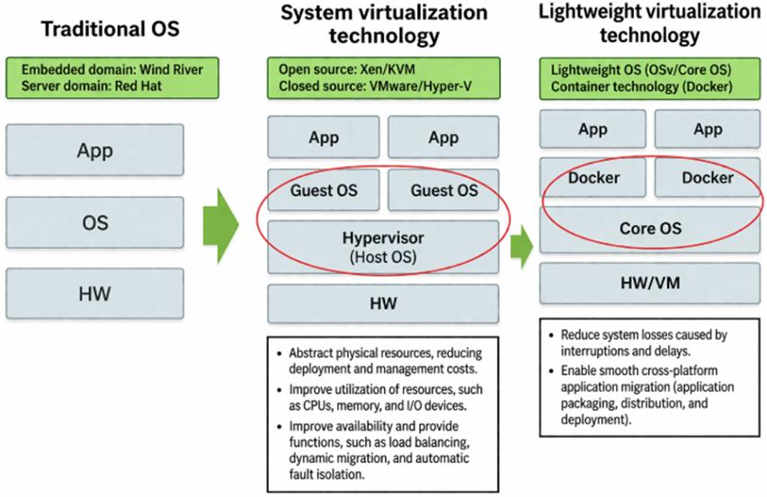

3. Typical-Case Operating Condition
3.1 Type-1 Hypervisor
Workload condition:
During semester registration, multiple students simultaneously access SIS and LMS applications. Database queries, authentication requests and web traffic increase.
What happens inside the virtualization layer?
The hypervisor schedules multiple vCPUs across the physical CPU cores. VM exits occur when guest operations require hypervisor intervention.
Guest memory is mapped to physical memory using hardware-assisted address translation.
Storage and network requests pass through virtual devices and virtual switches.
As the workload increases, CPU scheduling activity, virtual I/O processing and memory access increase.
Performance impact:
- Moderate CPU utilization.
- Increased VM scheduling activity.
- Higher database I/O latency.
- Increased network traffic.
- Slightly slower application response times.
EduCloud example: Hundreds of students attempt to log in and register for courses simultaneously. The hypervisor must manage concurrent requests from SIS, LMS and database VMs.
3.2 Type-2 Hypervisor
Workload condition:
Multiple development and departmental VMs operate simultaneously, with moderate CPU and storage usage.
What happens inside the virtualization layer?
Each guest VM sends requests to the hosted hypervisor. The hypervisor forwards operations through the host OS.
The host OS must manage its own processes while also handling guest VM scheduling, disk access and network communication.
As VM activity increases, context switches and host OS resource contention become more frequent.
Performance impact:
- Increased CPU scheduling overhead.
- More host OS context switching.
- Increased virtual disk latency.
- Reduced throughput under heavy I/O.
- Longer application response times.
EduCloud example: Departmental users run software development environments while university applications operate on the same infrastructure.
3.3 Container Virtualization
Workload condition:
Multiple containers execute web applications, APIs and distributed research services.
What happens inside the virtualization layer?
The host kernel schedules container processes and manages resource consumption through cgroups.
Network communication passes through virtual Ethernet interfaces, bridges or overlay networks.
Storage operations may pass through container filesystem layers and mounted volumes.
As container activity increases, packet processing and storage operations increase.
Performance impact:
- Increased kernel scheduling activity.
- Higher virtual network processing.
- Increased storage throughput demand.
- Moderate CPU and memory contention.
- Increased application response time.
EduCloud example: External research collaborators run Spark workers while university web applications continue serving students.
3.4 Typical-Case Architecture Diagram

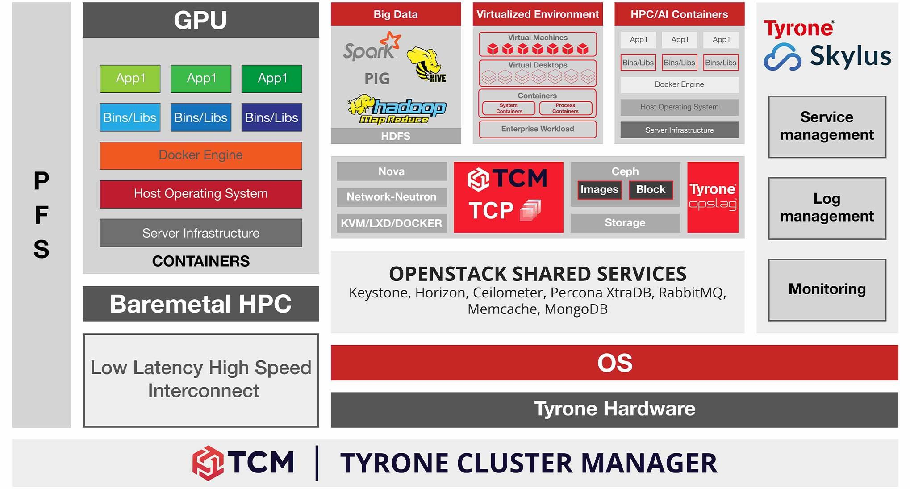
4. Worst-Case Operating Condition
The worst-case condition occurs when several workloads compete for the same physical resources. This is commonly known as the noisy-neighbour problem.
For EduCloud, external Spark and Hadoop workloads may consume significant CPU, RAM, storage bandwidth and network capacity while students are accessing SIS and LMS.
4.1 Type-1 Hypervisor
Workload condition:
- High CPU overcommitment, such as 8:1.
- Memory overcommitment.
- Heavy storage I/O.
- Live VM migration during registration.
- Multiple VMs competing for physical resources.
What happens inside the virtualization layer?
When too many VMs share physical CPU cores, the hypervisor must schedule more vCPUs than can execute simultaneously.
This increases CPU ready time and steal time. VM exits and virtual I/O operations also add processing overhead.
When physical RAM becomes insufficient, the hypervisor may use memory ballooning or swapping. Memory swapping causes additional disk operations and increases application latency.
During live migration, the hypervisor transfers VM memory pages over the network. This consumes CPU and network bandwidth that would otherwise support application traffic.
Performance impact:
- High CPU scheduling delays.
- Increased memory access latency.
- Storage I/O congestion.
- Reduced network throughput.
- Slow SIS login and database operations.
- Possible service timeouts.
EduCloud example: Spark workers process large research datasets while students simultaneously access the examination portal. Research workloads may consume resources needed by critical university applications.
4.2 Type-2 Hypervisor
Workload condition:
- Many guest VMs.
- High host OS CPU usage.
- Memory overcommitment.
- Simultaneous virtual disk operations.
- Heavy network traffic.
What happens inside the virtualization layer?
The hosted hypervisor depends on the host operating system to access physical resources.
Under heavy load, both the host OS and guest VMs compete for CPU and memory.
The host OS must schedule its own processes and virtual machine operations. This increases context switching and scheduling delays.
If physical memory becomes insufficient, the host OS may swap memory pages to disk. This creates additional I/O operations and affects all hosted VMs.
Performance impact:
- Increased context-switching overhead.
- High CPU contention.
- Longer storage response times.
- Increased memory swapping.
- Reduced application throughput.
EduCloud example: Several departmental development VMs execute large data-processing applications while the host OS handles multiple storage and network requests.
4.3 Container Virtualization
Workload condition:
- Large numbers of containers.
- High network communication.
- Heavy Spark/Hadoop data transfers.
- CPU and memory limits are configured poorly.
- Shared filesystem congestion.
What happens inside the virtualization layer?
Containers share the host OS kernel. When many containers execute simultaneously, the kernel must schedule a large number of processes and manage their resource consumption.
Spark and Hadoop workers exchange large volumes of data through virtual network interfaces and bridges.
High packet rates increase kernel network processing. Container storage layers and shared volumes also experience increased I/O demand.
If container memory limits are insufficient, applications may experience out-of-memory termination. If the host runs out of memory, the entire host can become unstable.
Performance impact:
- Increased kernel CPU utilization.
- Network packet-processing congestion.
- High storage latency.
- Memory pressure and possible OOM termination.
- Reduced Spark processing throughput.
- Slow application response times.
EduCloud example: External researchers execute multiple Spark jobs that continuously transfer large datasets, causing network and storage contention for university applications.
4.4 Worst-Case Architecture Diagram
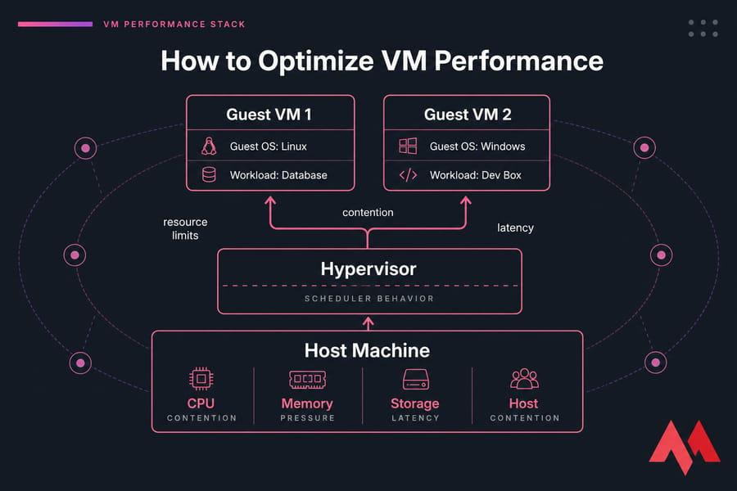
5. Comparative Analysis Under Three Operating Conditions
The following table summarizes how each architecture behaves under different workload conditions.
Architecture | Best case | Typical case | Worst case
Type-1 | Low VM count, low VM exits | Moderate VM scheduling and I/O | CPU contention, swapping and migration overhead
Type-2 | Low host OS and VM activity | Additional host scheduling and I/O | Host OS contention and heavy swapping
Containers | Few containers and low kernel activity | Moderate network and filesystem processing | Kernel contention, network congestion and OOM
6. Effect on Latency and Throughput
Latency represents the time required to complete an operation, whereas throughput represents the amount of work completed within a given period.
Architecture | Best-case latency | Typical-case latency | Worst-case latency
Type-1 | Low | Moderate | High
Type-2 | Low to moderate | Moderate to high | Very high
Containers | Very low | Low to moderate | High

Architecture | Best-case throughput | Typical-case throughput | Worst-case throughput
Type-1 | High | Stable | Reduced
Type-2 | Moderate to high | Reduced | Significantly reduced
Containers | High | High | Reduced under kernel and I/O contention
Qualitative comparison under the stated workload assumptions, not measured benchmark values.
6.1 Performance Behaviour Flowchart 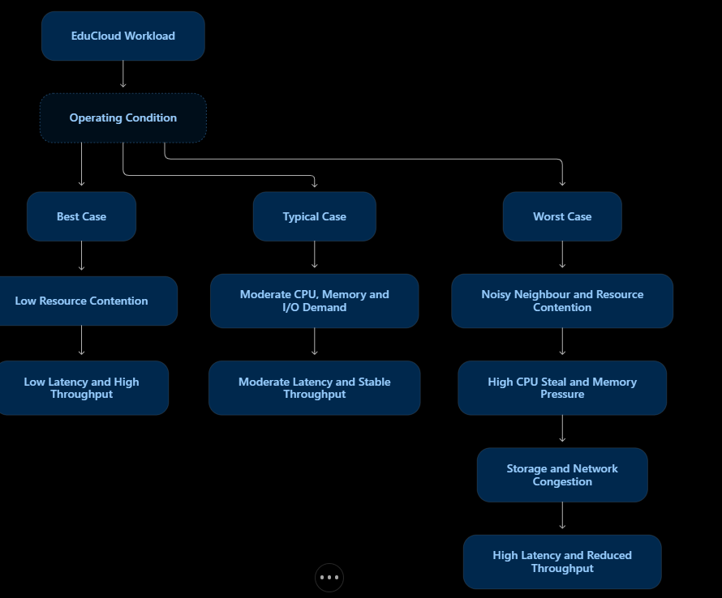
7. Relationship with Task 3 Quantitative Model
The Task 3 mathematical model helps explain how performance changes when workload intensity increases.
7.1 CPU Degradation Comparison
Using the illustrative CPU degradation values from Task 3:
Overcommit ratio | Type-1 | Type-2 | Containers
1:1 | 3.47% | 5.43% | 1.50%
2:1 | 5.44% | 8.35% | 2.49%
4:1 | 9.38% | 14.20% | 4.48%
8:1 | 17.26% | 25.90% | 8.46%
CPU degradation under increasing overcommitment
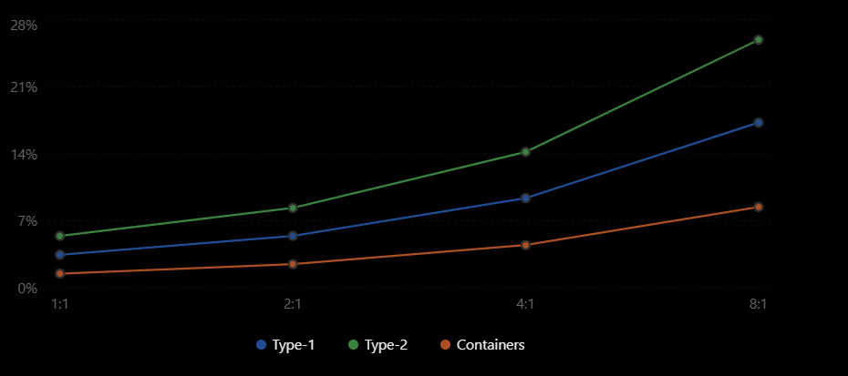Analysis:
- At 1:1, all three approaches operate within the 10% CPU degradation target.
- At 4:1, Type-1 and containers satisfy the assumed CPU target, while Type-2 exceeds it.
- At 8:1, Type-1 and Type-2 exceed the target, while containers remain within the illustrative CPU model.
However, CPU performance alone cannot guarantee the overall service-level target. Memory, storage and network bottlenecks must also be considered.

7.2 Memory and Network Effects
According to Task 3:
\[ N_{memory}=\frac{512-32}{8}=60 \]
Therefore, 60 workloads can be supported per host without memory overcommitment under the assumed memory demand.
If the workload count exceeds this capacity, memory ballooning or swapping may become necessary.
Similarly, network bandwidth per workload is:
\[ B_{eff}=\frac{25\times\eta}{N} \]
As the number of sharing workloads increases, the available bandwidth per workload decreases.
These two factors explain why a host can experience performance degradation even when its CPU utilization appears acceptable.
8. Recommended Performance Optimization for EduCloud
Problem | Recommended optimization
CPU contention | CPU reservations and scheduling priorities
Memory pressure | Memory reservations and workload limits
Storage congestion | NVMe storage and storage QoS
Network congestion | Network segmentation and bandwidth limits
Noisy neighbours | Separate tenant resource pools
Live migration overhead | Schedule migrations outside peak hours
Container overload | cgroups and container resource quotas
Host failure | High availability and VM failover
8.1 Recommended Workload Placement
- SIS and examination VMs: High-priority resource allocation and protected host capacity.
- LMS VMs: Balanced CPU and memory allocation with load balancing.
- Spark/Hadoop workloads: Separate research tenant resource pools with CPU, memory and I/O limits.
- Development containers: Lower-priority resource allocation with strict quotas.
9. Final Conclusion
The analysis demonstrates that virtualization performance depends on workload intensity and the way physical resources are shared.
- Type-1 virtualization provides strong performance in production environments, but excessive VM overcommitment, live migration and I/O contention can increase latency.
- Type-2 virtualization experiences additional host OS scheduling and I/O overhead, making it more vulnerable to heavy workloads.
- Container virtualization offers efficient resource utilization, but excessive container activity can cause kernel, storage and network contention.
For EduCloud, the recommended approach is to use Type-1 virtualization for critical university applications and isolated container environments for external Spark and Hadoop workloads.
CPU reservations, memory quotas, network QoS, storage isolation and workload placement policies should be implemented to reduce noisy-neighbour interference.
Final recommendation: EduCloud should prioritize SIS, LMS and examination workloads while allowing external research collaborators to use controlled resources. This provides better application responsiveness, security, throughput and scalability during both normal operations and semester registration periods.

TASK 5: Security Threat and Vulnerability Analysis
1. Introduction
Edu Cloud is a university private cloud that hosts important services such as the Student Information System (SIS), Learning Management System (LMS), examination portal and research applications. Since multiple virtual machines (VMs) and containers share the same physical infrastructure, security threats can affect more than one department or application.
A threat model identifies possible attackers, vulnerable components, security threats and their impact on the system. This analysis compares three approaches:
- Type-1 hypervisor (bare-metal virtualization).
- Type-2 hypervisor (hosted virtualization).
- OS-level virtualization (containers).
The main security objectives are:
- Confidentiality: Prevent unauthorized access to student records.
- Integrity: Prevent unauthorized modification of marks, attendance and personal details.
- Availability: Ensure SIS, LMS and examination services remain accessible.
2. Attack Surface of Each Architecture
An attack surface is the set of components through which an attacker may attempt to access or damage a system.
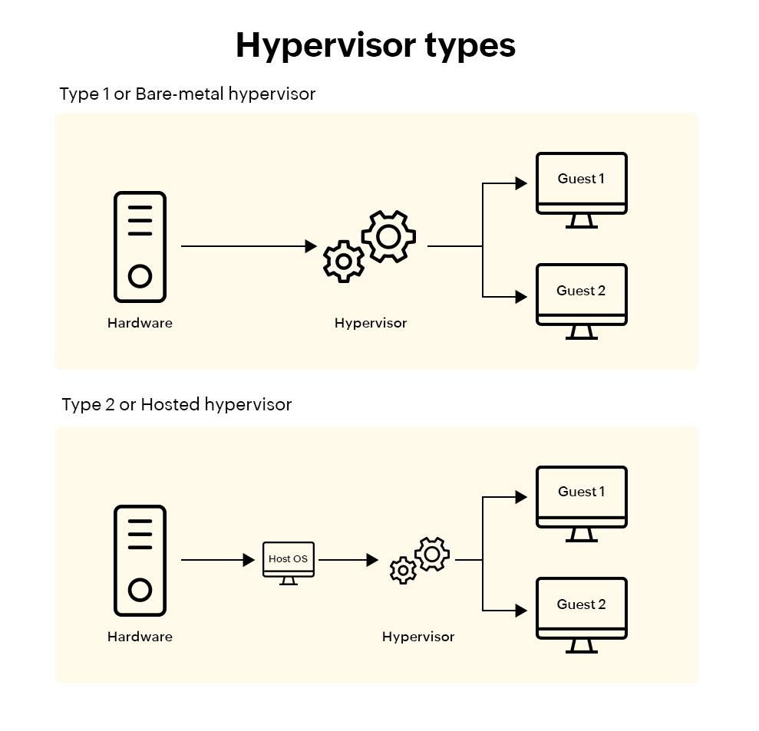
A. Type-1 Hypervisor
Runs directly on physical hardware. Its attack surface includes the hypervisor, device emulation, management interface, VM images, snapshots and virtual network.

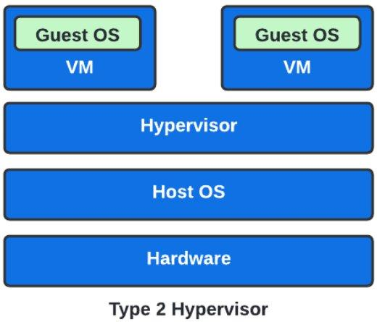
B. Type-2 Hypervisor
Runs above a host operating system. Its attack surface includes both the host OS and hypervisor, in addition to guest VMs, virtual devices, images and network connections.

C. OS-Level Virtualization (Containers)
Containers share the host operating-system kernel. The attack surface includes the shared kernel, container runtime, container images, orchestration and management interfaces, and virtual networks.
3. Major Threat Categories and Comparison
The following table maps important threats to the architectural features of each approach.
Threat category | Type-1 hypervisor | Type-2 hypervisor | Containers
VM/container escape | Possible if hypervisor or device emulation has a vulnerability | Higher exposure because both host OS and hypervisor are involved | Container escape can expose the shared host kernel
Cross-VM side-channel attack | Possible due to shared CPU cache and hardware resources | Possible due to shared physical hardware | Possible due to shared kernel and hardware resources
Unpatched systems | Outdated guest OS and hypervisor vulnerabilities | Guest OS, host OS and hypervisor vulnerabilities | Host kernel and container-runtime vulnerabilities
Image tampering | Modified VM images or snapshots can introduce malware | Modified VM images can affect hosted guest systems | Modified container images can introduce malicious software
Insecure live migration | Migration traffic can expose VM memory and data | VM transfer and host network can be exposed | Container data and orchestration traffic can be exposed during migration or redeployment
Virtual network attack | vSwitch sniffing, spoofing and unauthorized VM communication | Virtual network and host networking attacks | Container bridge, overlay network sniffing and spoofing
Comparison: Type-1 has a smaller software trust base than Type-2 because it does not depend on a general-purpose host OS. Type-2 has additional exposure through the host OS. Containers have efficient isolation, but their shared kernel makes a kernel-level vulnerability particularly serious.
4. Detailed Threat Analysis
Threat 1: VM Escape or Container Escape
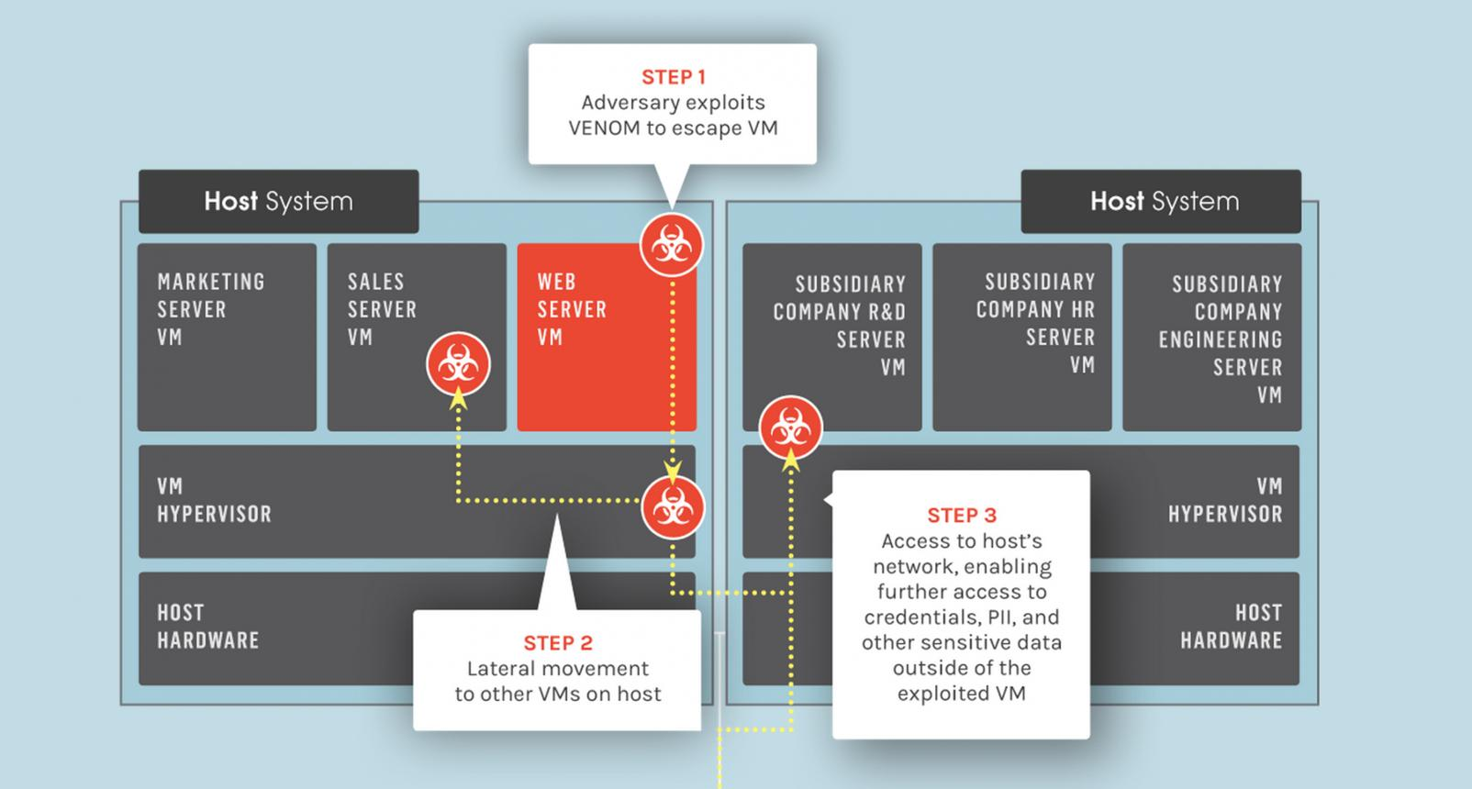
Meaning: An attacker exploits a vulnerability in the virtualization layer to break out of an isolated VM or container and access the host system or other workloads.
- Type-1: An attacker may exploit a hypervisor or virtual-device vulnerability. The hypervisor is a strong isolation boundary, but a successful escape can affect multiple VMs.
- Type-2: More exposed because the attack may target the hypervisor or the host operating system. Compromising the host can expose all hosted VMs.
- Containers: A container escape may exploit the shared host kernel or an over-privileged container. A successful attack can expose other containers and the host.
CIA impact: Student records may be disclosed (confidentiality), modified (integrity), or made unavailable by taking down the host (availability).
Threat 2: Cross-VM Side-Channel Attack
Meaning: An attacker observes shared hardware behaviour, such as CPU cache timing, to infer information about another workload.
- A malicious VM may attempt to infer sensitive information from another VM.
- Type-2: The same shared-hardware risk exists, with additional host OS scheduling and resource-sharing layers. 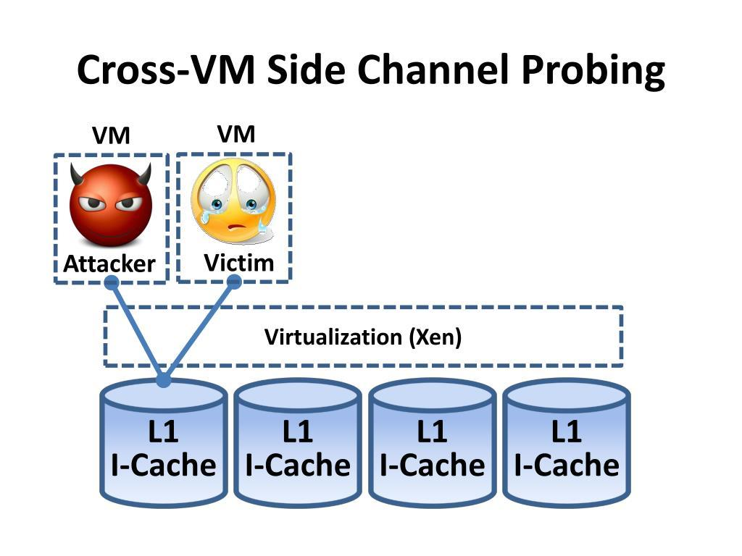
- Containers: Containers share the host kernel and physical CPU resources. Isolation of processes does not completely eliminate hardware side channels.
CIA impact: Mainly threatens confidentiality. Sensitive authentication data or information processed by student applications could potentially be inferred.
Threat 3: Unpatched Guests and Hypervisor or Runtime Vulnerabilities

Meaning: Outdated operating systems, hypervisors or container runtimes may contain known security weaknesses that attackers can exploit.
- Type-1: Outdated guest kernels or hypervisor software may allow unauthorized access or privilege escalation.
- Type-2: More exposed because the host OS, hypervisor and guest OS all require security updates.
- Containers: A vulnerable shared host kernel or container runtime can affect multiple containers at once. Updating only the application inside a container is not sufficient.
CIA impact: Attackers may steal student information, alter examination data or disrupt SIS and LMS services.
Threat 4: VM or Container Image Tampering
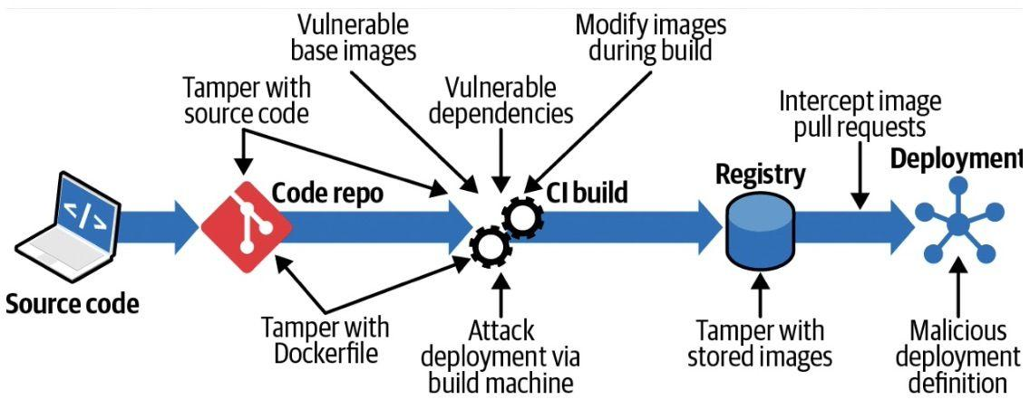

Meaning: An attacker modifies a VM image, snapshot or container image to insert malware, backdoors or unauthorized software.
- Type-1: Freely copied VM images may contain malware or outdated software. Starting a modified image can introduce threats into the private cloud.
- Type-2: Downloaded or copied guest images may compromise the host environment or other hosted applications if they contain malicious software.
- Containers: Untrusted container images may contain malicious packages or vulnerable dependencies. A compromised image can be deployed repeatedly across many containers.
CIA impact: Malware may steal student records, change marks or attendance, and interrupt application services.
Threat 5: Insecure Live Migration and Virtual-Network Attacks
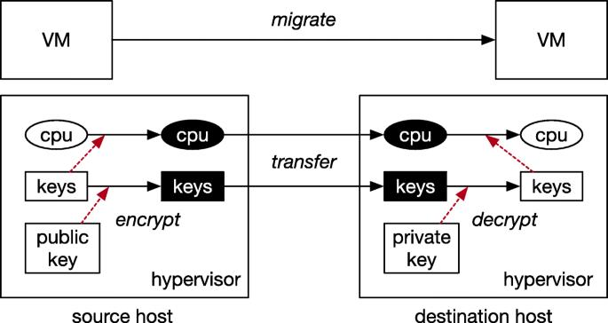Meaning: Attackers may intercept, manipulate or impersonate traffic moving between virtual machines, physical hosts or virtual networks.
- Type-1: Unprotected live migration may expose VM memory and running application data. A misconfigured virtual switch may also permit sniffing or spoofing.
- Type-2: Migration and virtual networking depend on the host OS networking stack, creating additional points that need protection.
- Containers: Misconfigured bridges, overlay networks or orchestration interfaces may allow unauthorized container-to-container communication or traffic interception.
CIA impact: Intercepted traffic threatens confidentiality; altered traffic threatens integrity; network disruption threatens availability.
5. CIA Impact on Student Records
Security objective | Possible attack | Impact on EduCloud
Confidentiality | VM escape, side-channel attack, network sniffing | Exposure of student names, personal details, login credentials and academic records
Integrity | Image tampering, network spoofing, privilege escalation | Unauthorized modification of marks, attendance, examination results and student details
Availability | Host compromise, ransomware, resource exhaustion, network attack | SIS, LMS and examination portal downtime; failed logins and interrupted registration
Example: If an attacker compromises the SIS VM and changes examination marks, the attack affects the integrity of student records. If the attacker steals student details, confidentiality is affected. If the attacker shuts down the SIS host, availability is affected. 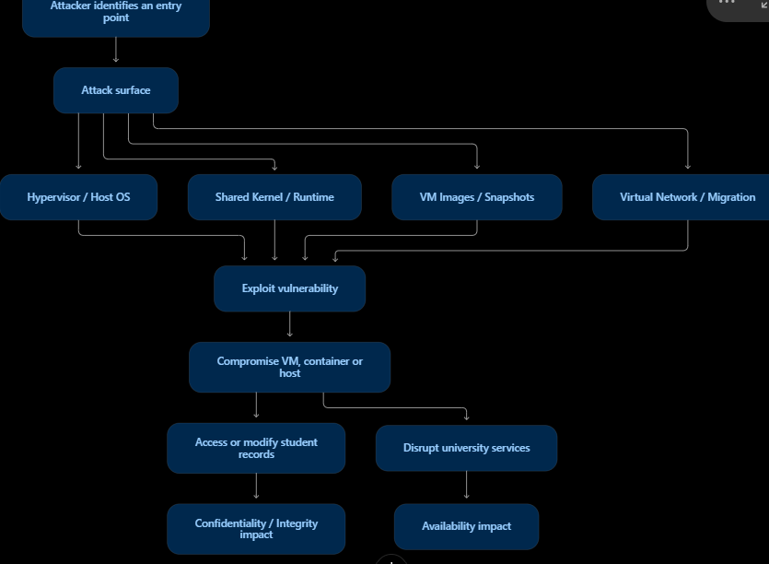
. Conclusion
The threat analysis shows that all three virtualization approaches have security risks, but their exposure differs because of their architecture and trust boundaries. Type-1 hypervisors provide stronger isolation for critical university services than Type-2 hypervisors. Type-2 systems have an additional attack surface through the host operating system. Containers provide efficient resource sharing, but a shared-kernel vulnerability can affect multiple containers.
Recommended solution for EduCloud: Use Type-1 hypervisors for SIS, LMS and examination services. Run external Spark/Hadoop research workloads inside isolated VMs with containers, strict resource limits and network segmentation. Apply regular security patches, image verification, encrypted migration, access control and continuous monitoring to protect student information.
TASK 6: Formulate the Isolation–Performance Trade-off
EduCloud – Virtualization Architectures | 3 Marks
1. Introduction
The isolation–performance trade-off describes the balance between security isolation and resource efficiency in a virtualized cloud environment.
In EduCloud, stronger isolation protects sensitive student records, examination results and university applications. However, stronger isolation may require dedicated hosts and additional resources, reducing VM density and increasing infrastructure cost.
Therefore, EduCloud must select a virtualization architecture that provides sufficient security while maintaining acceptable performance and resource utilization.
2. Decision Variables
The following variables are considered for the EduCloud infrastructure.
Variable | Description | Possible values
\(A\) | Virtualization approach | Type-1, Type-2, Containers
\(N\) | Number of workloads per host | 1–60 under the memory assumption
\(R\) | CPU overcommit ratio | 1:1, 2:1, 4:1, 8:1
\(H_d\) | Dedicated host allocation | 1 = dedicated, 0 = shared
\(S\) | SMT configuration | 1 = enabled, 0 = disabled
\(I\) | Isolation level | High, Medium, Low
Here, dedicated hosts mean that critical workloads are placed on separate physical hosts instead of sharing hosts with external research workloads.
3. Objective Function
The main objective is to maximise workload density while minimising infrastructure cost and maintaining strong isolation.
A combined decision function can be written as:
\[ \boxed{\max Z = \alpha D-\beta C-\gamma Q} \]
Where:
- \(Z\) = Overall optimization score.
- \(D\) = Number of supported workloads per host.
- \(C\) = Infrastructure and operating cost.
- \(Q\) = Security risk or isolation penalty.
- \(\alpha,\beta,\gamma\) = Importance weights assigned to each objective.
For EduCloud, the security penalty should receive a high weight for SIS and examination workloads because they contain sensitive student information.
4. Performance Constraint
From Task 3, the maximum acceptable performance degradation is 10%.
The degradation model is:
\[ D_g=1-(1-H)(1-S_t) \]
Where:
- \(H\) = Virtualization overhead.
- \(S_t\) = CPU scheduling or contention overhead.
- \(D_g\) = Total performance degradation.
Using the assumptions from Task 3:
CPU overcommit | Type-1 | Type-2 | Containers
1:1 | 3.47% | 5.43% | 1.50%
2:1 | 5.44% | 8.35% | 2.49%
4:1 | 9.38% | 14.20% | 4.48%
8:1 | 17.26% | 25.90% | 8.46%
Illustrative estimates from the Task 3 assumptions, not measured benchmark results.
Therefore, the maximum tested overcommit ratios satisfying the 10% limit are:
- Type-1: 4:1
- Type-2: 2:1
- Containers: 8:1
5. Isolation and Security Constraints
Based on Task 5, the following isolation requirements are applied:
Workload | Required isolation | Reason
SIS | High | Contains confidential student information
LMS | High | Stores student profiles and academic activities
Examination portal | Very high | Protects examination questions, marks and results
External Spark/Hadoop workloads | High separation from university services | Prevents external tenants from accessing university data
Development workloads | Medium | Used for testing and development
Security rule: External research workloads must not share the same security boundary as SIS and examination workloads. Containers used by external collaborators should run inside isolated VMs with strict network and resource controls.
6. Resource and Infrastructure Constraints
EduCloud has 16 physical hosts, each with 64 CPU cores and 512 GB RAM.
Assuming 32 GB is reserved for the host and hypervisor:
\[ RAM_{usable}=512-32=480\ GB \]
Average memory required per VM = 8 GB.
\[ N_{memory}=\frac{480}{8}=60\ VMs \]
Thus, the simplified memory-based density limit is 60 VMs per host.
Other constraints include:
- Total physical hosts must not exceed 16.
- Total CPU capacity must not exceed the selected overcommit limit.
- Total memory demand must not exceed 480 GB per host.
- Performance degradation must remain at or below 10%.
- SIS and examination services must satisfy high isolation requirements.
7. Combined Isolation–Performance Decision Model
The final decision can be represented as:
\[ \boxed{ \begin{aligned} \max \quad & Z=\alpha D-\beta C-\gamma Q\\ \text{Subject to:}\quad & D_g\leq 10\%\\ & RAM_{workload}\leq480\ GB\\ & CPU_{overcommit}\leq R_{max}\\ & Hosts_{used}\leq16\\ & I_{SIS}\geq I_{high}\\ & I_{Exam}\geq I_{high} \end{aligned} } \]
This means EduCloud can increase workload density only when performance and security requirements are satisfied.
8. Trade-off Flowchart
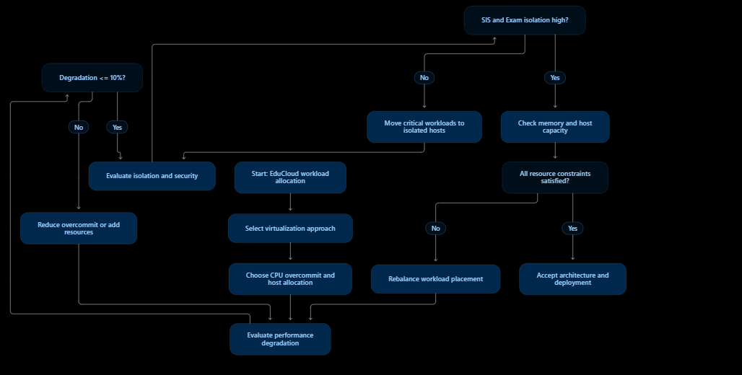

9. Recommended Decision for EduCloud
Workload | Recommended approach | Allocation strategy
SIS | Type-1 | Dedicated or strongly isolated host pool
LMS | Type-1 | Isolated VM resource pool
Examination portal | Type-1 | Dedicated host pool during examinations
External Spark/Hadoop | Containers inside Type-1 VMs | Separate tenant VMs, CPU and memory quotas
Development and testing | Type-2 | Shared development infrastructure
10. Conclusion
The isolation–performance model shows that maximum workload density should not be the only objective of EduCloud. Security and performance must be considered together. Type-1 virtualization is recommended for critical university services because it provides a stronger isolation boundary. Containers inside isolated VMs are recommended for external research workloads because they provide efficient resource utilization while maintaining tenant separation.
Final decision: EduCloud should maximise workload density only after satisfying the 10% performance degradation limit, memory capacity and high-isolation requirements for SIS and examination systems.
TASK 7: Evaluate Mitigation Strategies
EduCloud – Virtualization Architectures | 4 Marks
1. Introduction
In Task 5, several security threats were identified in EduCloud, including VM escape, cross-VM side-channel attacks, unpatched systems, image tampering and virtual-network attacks.
To reduce these threats, EduCloud must implement security mitigation strategies without causing excessive performance degradation or reducing workload density.
The following analysis evaluates six mitigation strategies using the performance assumptions established in Task 3. The estimated costs are illustrative engineering estimates, not measured benchmark results.
2. Mitigation Strategies
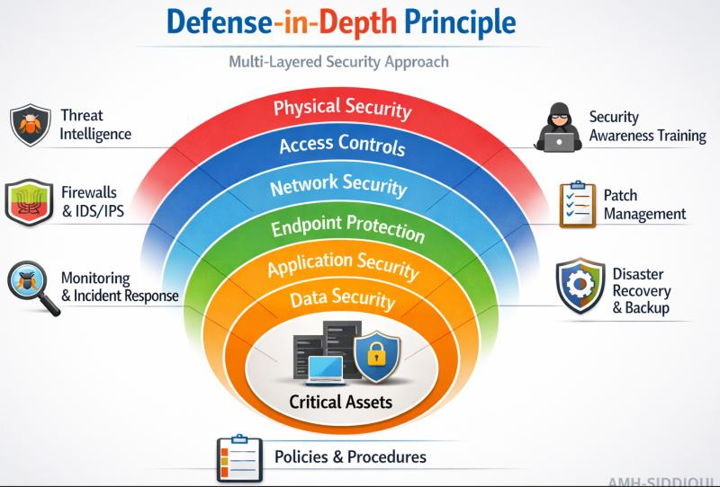Mitigation 1: Disable SMT (Simultaneous Multithreading)
Threat addressed: Cross-VM side-channel attacks.
SMT allows multiple hardware threads to share one physical CPU core. This sharing may create opportunities for side-channel attacks through shared processor resources.
- Security benefit: Disabling SMT reduces simultaneous sharing of core execution resources and can reduce certain side-channel attack opportunities.
- Residual risk: Other shared resources, such as last-level CPU caches and memory, may still permit side-channel attacks.
- Performance cost: Assume disabling SMT reduces aggregate CPU throughput by approximately 20% for the workloads being modelled.
Using the Task 3 Type-1 baseline at 1:1:
\[ CPU_{effective}=64(1-0.015)(1-0.02) \]
\[ =61.78\text{ effective cores} \]
After disabling SMT, assuming a 20% throughput reduction:
\[ 61.78\times0.80=49.42 \]
Estimated CPU capacity loss: 20%
SIS decision: Acceptable when strong protection against relevant side-channel threats is required. The university should validate the actual workload performance before deployment.
Mitigation 2: Kernel Page-Table Isolation (KPTI)
Threat addressed: Kernel memory disclosure and certain privilege-boundary attacks.
KPTI separates user-space and kernel-space page-table mappings to reduce the possibility of unauthorized access to sensitive kernel memory.
- Security benefit: Reduces exposure to attacks that exploit certain CPU vulnerabilities to read privileged kernel memory.
- Residual risk: Does not prevent every side-channel attack, VM escape or malicious administrator action.
- Performance cost: Assume an additional 2% CPU overhead.
Using the Task 3 Type-1 effective capacity:
\[ CPU_{new}=61.78(1-0.02) \]
\[ =60.54\text{ effective cores} \]
\[ Loss=61.78-60.54=1.24\text{ cores} \]
Estimated CPU capacity loss: 2%
SIS decision: Acceptable. The small estimated performance cost is justified by the additional kernel-memory protection.
Mitigation 3: Dedicated Hosts for Sensitive Tenants
Threat addressed: Cross-VM attacks, noisy-neighbour problems and unauthorized access between tenants.
EduCloud can allocate separate physical hosts to sensitive university services instead of allowing them to share hosts with external research workloads.
- Security benefit: Reduces direct sharing of physical CPU, memory and host-level resources between critical university services and external tenants.
- Residual risk: Network attacks, management-plane compromise and vulnerabilities within the dedicated host can still occur.
- Performance and density cost: Assume two of the 16 hosts are reserved for critical SIS and examination workloads.
\[ Hosts_{reserved}=2 \]
\[ Capacity\ reserved=\frac{2}{16}\times100=12.5\% \]
The shared pool will have:
\[ 16-2=14\text{ hosts} \]
Shared-pool capacity reduction: 12.5%
SIS decision: Highly acceptable. Protecting student records and examination data is more important than maximising shared-host density. The reserved hosts still provide computing capacity; they are not wasted resources.
Mitigation 4: Image Signing and Vulnerability Scanning
Threat addressed: VM image tampering and malicious container images.
EduCloud should use trusted image repositories, digital signatures and vulnerability scanning before deploying VM or container images.
- Security benefit: Digital signatures verify image authenticity and integrity. Vulnerability scanning identifies outdated packages and known weaknesses.
- Residual risk: A correctly signed image may still contain vulnerable or malicious software if the trusted source is compromised.
- Performance and density cost: Assume a 0.5% CPU-equivalent overhead for runtime image-integrity verification and monitoring. Image scanning itself is performed before deployment and does not continuously consume production CPU.
Using the Task 3 Type-1 baseline:
\[ CPU_{new}=61.78(1-0.005) \]
\[ =61.47\text{ effective cores} \]
\[ Loss=0.31\text{ cores} \]
Estimated CPU capacity loss: 0.5%
SIS decision: Highly acceptable. It provides important protection against modified VM images and requires very little estimated runtime capacity.
Mitigation 5: Network Micro-Segmentation
Threat addressed: Virtual-network sniffing, spoofing and unauthorized communication between tenants.
Micro-segmentation divides the cloud network into smaller security zones. For example, SIS, LMS, examination and external research workloads can be placed in separate network segments with firewall rules controlling communication.
- Security benefit: Prevents unrestricted communication between departments and limits the spread of attacks.
- Residual risk: Incorrect firewall rules, compromised network controllers and attacks within an allowed segment may still cause security problems.
- Performance cost: Assume network efficiency decreases from 95% to 92% because of additional filtering and inspection.
Using the Task 3 network model:
\[ B_{eff}=\frac{B\times\eta}{N} \]
For 25 Gbps network capacity and 10 workloads:
Before mitigation:
\[ B_{before}=\frac{25\times0.95}{10}=2.375\ Gbps \]
After mitigation:
\[ B_{after}=\frac{25\times0.92}{10}=2.30\ Gbps \]
\[ Loss=\frac{2.375-2.30}{2.375}\times100 =3.16\% \]
Estimated network throughput loss: 3.16%
SIS decision: Acceptable. A small estimated network-throughput reduction is justified by preventing unauthorized access to student databases and examination systems.
Mitigation 6: Secure or Sandboxed Container Runtime
Threat addressed: Container escape and shared-kernel vulnerabilities.
External Spark/Hadoop workloads should run in isolated VMs, with containers managed using hardened or sandboxed runtimes. Apply restricted capabilities, namespaces, cgroups and seccomp policies.
- Security benefit: Reduces container privileges and limits the damage caused by a compromised application.
- Residual risk: Shared-kernel vulnerabilities and runtime configuration mistakes may still allow attacks.
- Performance cost: Assume an additional 2% CPU overhead for sandboxing and security checks, on top of the 0.5% container overhead assumed in Task 3.
Using the Task 3 container baseline:
\[ CPU_{baseline}=64(1-0.005)(1-0.01) \]
\[ =63.04\text{ effective cores} \]
After additional sandboxing overhead:
\[ CPU_{new}=63.04(1-0.02) \]
\[ =61.78\text{ effective cores} \]
\[ Loss=63.04-61.78=1.26\text{ cores} \]
Additional CPU capacity loss: 2%
SIS decision: Acceptable for external research workloads. For SIS, use Type-1 VMs as the main security boundary rather than relying only on container isolation.

3. Comparative Evaluation of Mitigations
Mitigation | Main threat addressed | Estimated performance or density cost | SIS suitability
Disable SMT | Cross-VM side-channel attacks | 20% CPU throughput loss (assumed) | Acceptable if required by risk assessment
KPTI | Kernel memory disclosure | 2% CPU capacity loss (assumed) | Highly acceptable
Dedicated hosts | Cross-tenant attacks | 12.5% shared-pool capacity reserved | Highly acceptable
Image signing and scanning | Image tampering | 0.5% runtime CPU overhead (assumed) | Highly acceptable
Network micro-segmentation | Sniffing and spoofing | 3.16% network throughput loss (assumed) | Highly acceptable
Sandboxed container runtime | Container escape | 2% additional CPU overhead (assumed) | Suitable as an additional control, not the sole SIS isolation boundary
4. Overall Performance and Density Analysis
Task 3 established the following baseline assumptions:
- Physical CPU cores per host = 64.
- RAM per host = 512 GB.
- Host and hypervisor memory reserve = 32 GB.
- Average VM memory demand = 8 GB.
- Memory-based density = 60 VMs per host.
- Type-1 CPU degradation at 1:1 overcommit = 3.47%.
The mitigation costs can be interpreted as follows:
Estimated performance cost of mitigations
Illustrative percentage costs. CPU and network costs are different metrics and should not be interpreted as directly equivalent.
0 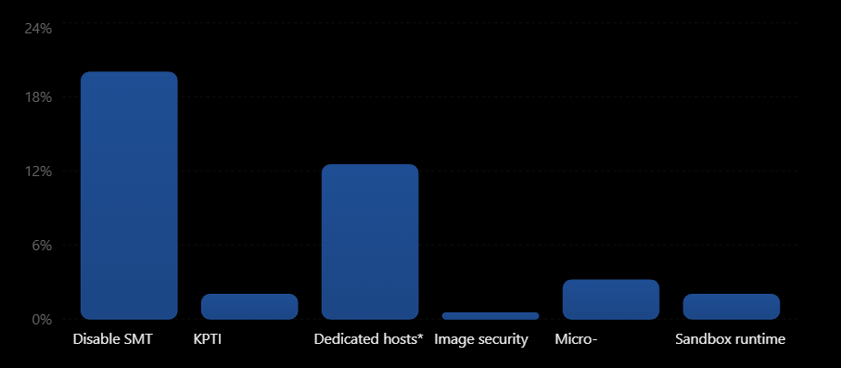runtime
*Dedicated-host cost is the percentage of total host capacity reserved for sensitive workloads, not a loss of physical computing capacity. All figures are illustrative assumptions.
Important interpretation: The 60-VM memory limit from Task 3 remains unchanged by most of these software mitigations because the memory allocation assumption is unchanged. However, disabling SMT can reduce CPU throughput, while dedicated-host allocation reduces the number of hosts available to the shared workload pool. Actual VM density depends on workload CPU and memory demand.
5. Mitigation Implementation Flowchart 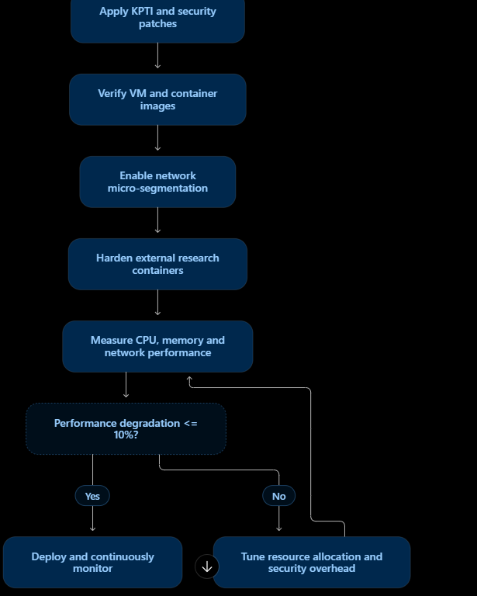

6. Final Recommendation for EduCloud
The following combination provides a suitable balance between security and performance:
- SIS and examination portal: Use dedicated Type-1 host pools, KPTI, regular patching and image verification.
- LMS: Use Type-1 virtualization with strong access control and network segmentation.
- External Spark/Hadoop: Use sandboxed containers inside isolated VMs with CPU and memory quotas.
- All workloads: Apply network micro-segmentation, secure management access and continuous monitoring.
- SMT: Disable it for sensitive workloads if the threat assessment requires it and available CPU capacity can support the expected demand.
7. Conclusion
The analysis shows that security mitigations introduce different performance costs. Disabling SMT has the highest estimated CPU throughput cost, while KPTI and image verification have relatively small costs. Dedicated hosts reduce shared-pool capacity but provide stronger tenant isolation. Network micro-segmentation and sandboxed container runtimes improve security with manageable estimated overhead.
Final decision: For EduCloud, the security benefits of dedicated hosts, KPTI, image signing and network micro-segmentation justify their estimated costs for SIS and examination services. Security should be prioritised for sensitive student records, while resource-efficient and sandboxed containers can be used for external research workloads.
TASK 8: Implement and Test
EduCloud – Virtualization Architectures | 4 Marks
1. Introduction
The purpose of this task is to build a small test environment and compare the performance, resource usage and isolation of the three virtualization approaches selected in Task 1:
- Type-1: KVM/QEMU running on a Linux host with KVM as the bare-metal virtualization layer.
- Type-2: Oracle VirtualBox running on a host operating system.
- OS-level virtualization: Docker containers sharing the host kernel.
For an additional security comparison, Kata Containers or gVisor can be tested as a hardened container option.
The experiments use identical CPU, memory, storage and network allocations wherever possible. The tests measure CPU performance, disk I/O, network throughput, memory behaviour and the effect of a noisy neighbour.
Practical note: The following is a reproducible test procedure and command set. I cannot access or run tests on your laptop from this chat, so the results must be collected on your machine. Do not present the example configuration as measured experimental results.
2. Test Environment and Configuration
2.1 Hardware and software requirements
Component | Recommended configuration
Host computer | Laptop or desktop with 8 GB RAM or more
Processor | 4 or more physical CPU cores, if available
Operating system | Ubuntu Linux 22.04/24.04
Type-1 platform | KVM/QEMU with libvirt
Type-2 platform | Oracle VirtualBox
Container platform | Docker Engine
Benchmark tools | stress-ng, fio, iperf3, sysbench
Monitoring | htop, free, iostat, virsh, docker stats
For a laptop, nested virtualization may be required if KVM or VirtualBox is running inside another virtual machine. Hardware virtualization support should be enabled in BIOS/UEFI.
2.2 Identical resource allocation
Use the following common configuration for each test instance.
Resource | Allocation per instance
Virtual CPU | 1 vCPU
Memory | 512 MB
Virtual disk | 4 GB
Network | Same host network and test path
CPU overcommit | 1:1 initially
Test repetitions | 3 runs per workload
For memory-intensive testing, use a smaller controlled allocation, such as 256 MB per instance, and ensure that the total demand does not cause uncontrolled host swapping.
Scale: Test 1, 2, 4, 8 and 16 instances if the host has sufficient resources. If the laptop cannot safely support 16 instances, report the highest completed scale and explain the hardware limitation. Do not compare a 16-instance run in one approach against a 4-instance run in another as if they were equivalent.
3. Architecture of the Test Environment
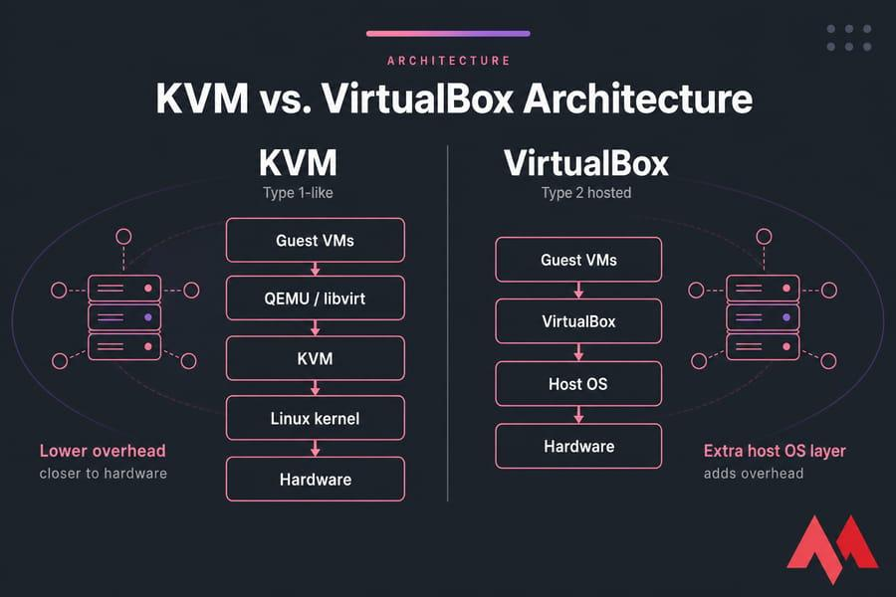4. Install the Required Tools
On an Ubuntu test host, install the benchmark and virtualization tools:
sudo apt update
sudo apt install -y qemu-kvm libvirt-daemon-system \
libvirt-clients virt-manager virtualbox \
docker.io stress-ng fio iperf3 sysbench \
htop sysstat
Enable the services:
sudo systemctl enable --now libvirtd
sudo systemctl enable --now docker
Check hardware virtualization:
egrep -c '(vmx|svm)' /proc/cpuinfo
A value greater than zero indicates that CPU virtualization extensions are visible to Linux.
Check KVM:
ls -l /dev/kvm
Check Docker:
docker version
Check VirtualBox:
VBoxManage --version
If VirtualBox and KVM cannot run together on the same host, run their experiments separately, rebooting or changing the hypervisor configuration as required.
5. Create the Test Instances
First, prepare one Ubuntu guest template for both KVM and VirtualBox. Install the same benchmark tools inside that guest:
sudo apt update
sudo apt install -y stress-ng fio iperf3 sysbench sysstat
Configure the template with 1 vCPU, 512 MB RAM and a 4 GB virtual disk. Shut it down after installation. Use that same guest image and software version for every VM test.
5.1 KVM/QEMU – Type-1 test
Create copies from the prepared KVM template:
for i in 1 2 4 8 16
do
for n in $(seq 1 $i)
do
sudo virt-clone \
--original ubuntu-template \
--name kvm-test-$i-$n \
--file /var/lib/libvirt/images/kvm-test-$i-$n.qcow2
done
done
Start a selected group of VMs, for example, eight:
for n in $(seq 1 8)
do
sudo virsh start kvm-test-8-$n
done
Check the running VMs:
sudo virsh list
5.2 VirtualBox – Type-2 test
Create VM copies from the same prepared Ubuntu guest template:
for i in 1 2 4 8 16
do
for n in $(seq 1 $i)
do
VBoxManage clonevm ubuntu-template \
--name vb-test-$i-$n \
--register
done
done
Start eight VMs in headless mode:
for n in $(seq 1 8)
do
VBoxManage startvm vb-test-8-$n --type headless
done
Check running VMs:
VBoxManage list runningvms
Ensure each VM has the same 1-vCPU and 512-MB allocation as the KVM guest.
5.3 Docker – Container test
Create a Dockerfile so that every container has the same benchmark utilities:
FROM ubuntu:24.04

RUN apt-get update && apt-get install -y \
stress-ng fio iperf3 sysbench \
&& rm -rf /var/lib/apt/lists/*

CMD ["sleep", "infinity"]
Build the image:
docker build -t educloud-test .
Create 1, 2, 4, 8 or 16 containers with the same resource limits:
for n in $(seq 1 8)
do
docker run -d \
--name docker-test-$n \
--cpus=1 \
--memory=512m \
--memory-swap=512m \
educloud-test
done
Check container resource usage:
docker stats
For the 1, 2, 4 and 16 instance experiments, change the loop limit accordingly.
6. Workload Experiments
Run each workload three times for every instance count. Use the same duration, test data size and resource allocation across all approaches.
Experiment 1: CPU-bound workload
Purpose: Measure CPU processing performance under different levels of virtualization density.
Run inside each VM or container:
stress-ng --cpu 1 --timeout 60s --metrics-brief
Record:
- Total CPU operations or bogo operations.
- CPU utilization.
- Execution time.
- CPU scheduling delay, if available.
Experiment 2: Disk I/O workload
Purpose: Measure storage performance and identify I/O overhead.
Run:
fio --name=educloud-disk \
--filename=/tmp/testfile \
--size=256M \
--rw=randrw \
--bs=4k \
--iodepth=16 \
--direct=1 \
--runtime=60 \
--time_based \
--group_reporting
Record:
- Read IOPS.
- Write IOPS.
- Read and write throughput.
- Average and 95th-percentile latency.
Use the same virtual disk type and storage location for both VM platforms. For Docker, use a dedicated volume with the same underlying host storage.
Experiment 3: Network workload
Purpose: Measure network throughput and latency between instances and a common test server.
On the host, start the server:
iperf3 -s
Inside each VM or container, run:
iperf3 -c HOST_IP -t 60
Replace HOST_IP with the host's reachable IP address.
Record:
- Network throughput in Gbps or Mbps.
- Retransmissions.
- Transfer time.
- Network latency, using an additional ping test.
Experiment 4: Memory-intensive workload
Purpose: Evaluate memory allocation, memory throughput and resource contention.
Run inside each VM or container:
sysbench memory \
--memory-block-size=1M \
--memory-total-size=1G \
--threads=1 run
Record:
- Memory transfer speed.
- Total execution time.
- Memory usage.
- Swap activity and out-of-memory events.
Keep the memory test size within the instance's allocation. If the 512-MB instance cannot safely run a 1-GB test, reduce --memory-total-size to 256M for every approach and document that common test size.
7. Noisy-Neighbour Experiment
Purpose: Identify how one resource-intensive workload affects the performance of other workloads sharing the same physical host.
A noisy neighbour is a VM or container that consumes excessive CPU, memory, disk or network resources, reducing the performance available to other tenants.
Procedure:
- Start four instances using the same virtualization approach.
- Run a CPU benchmark in all four instances and record the baseline performance.
- Select one instance as the noisy neighbour.
- Run a high CPU workload in that instance.
- Repeat the benchmark in the remaining three instances.
- Compare the results before and during interference.
Run the following command in the noisy-neighbour instance:
stress-ng --cpu 1 --cpu-load 100 --timeout 120s
Run the normal CPU benchmark in the other instances:
stress-ng --cpu 1 --timeout 60s --metrics-brief
Calculate the performance degradation:
\[ D=\frac{P_{before}-P_{during}}{P_{before}}\times100 \]
Where:
- \(P_{before}\) = Performance before interference.
- \(P_{during}\) = Performance during interference.
- \(D\) = Percentage performance degradation.
Repeat the same procedure for KVM, VirtualBox and Docker.
8. Security Validation
Selected security property: Container namespace and kernel isolation.
The experiment verifies that Docker containers have separate process and network namespaces but share the host operating-system kernel.
Run:
docker run -d --name security-test ubuntu:24.04 sleep infinity
Find the container process ID:
docker inspect -f '{{.State.Pid}}' security-test
Inspect its namespaces:
sudo ls -l /proc/CONTAINER_PID/ns/
Replace CONTAINER_PID with the process ID returned by Docker.
Compare the host and container kernel versions:
uname -r
docker exec security-test uname -r
Expected observation:
- The container has its own process and network namespace identifiers.
- The host and container report the same underlying Linux kernel version.
- This demonstrates that Docker provides process and network isolation but does not provide a separate guest kernel.
Clean up:
docker rm -f security-test
This validates one isolation property in practice. It does not prove that container escape is impossible.
9. Result Recording Tables
Record the actual measurements obtained from your computer in the following tables.
9.1 CPU performance comparison
Instances | KVM CPU result | VirtualBox CPU result | Docker CPU result
1 | ___ | ___ | ___
2 | ___ | ___ | ___
4 | ___ | ___ | ___
8 | ___ | ___ | ___
16 | ___ | ___ | ___
Record bogo operations per second or another consistent CPU benchmark metric.
9.2 Disk and network performance
Approach | Disk IOPS | Disk latency (ms) | Network throughput (Mbps)
KVM | ___ | ___ | ___
VirtualBox | ___ | ___ | ___
Docker | ___ | ___ | ___
9.3 Memory performance
Approach | Memory throughput | Memory usage | Swap activity
KVM | ___ | ___ | ___
VirtualBox | ___ | ___ | ___
Docker | ___ | ___ | ___
9.4 Noisy-neighbour results
Approach | Baseline performance | Performance during interference | Degradation (%)
KVM | ___ | ___ | ___
VirtualBox | ___ | ___ | ___
Docker | ___ | ___ | ___
10. Comparison and Expected Observations
The following are architectural expectations, not experimental results. Your measured values may differ depending on the processor, storage device, host OS and hypervisor configuration.
Test | KVM / Type-1 | VirtualBox / Type-2 | Docker / Containers
CPU | Low virtualization overhead expected | Additional host OS overhead may occur | Usually low overhead
Disk I/O | Depends on virtual disk and storage backend | Additional host filesystem processing may occur | Depends on storage driver and volume configuration
Network | Depends on virtual NIC and virtual switch | Depends on host networking and virtual NIC | Depends on bridge or host networking
Memory | Guest memory is separately allocated | Guest memory is managed through host OS | Containers share the host kernel
Noisy neighbour | Hypervisor scheduling and resource limits affect interference | Host OS and hypervisor scheduling affect interference | cgroups can limit CPU and memory usage

Conclusion
The proposed test environment allows EduCloud's three virtualization approaches to be compared under identical resource allocations and workloads. CPU, disk, network and memory benchmarks help identify performance overhead, while the noisy-neighbour experiment demonstrates the effect of resource contention. Namespace and kernel inspection provides practical evidence of container isolation.
The results can be used to validate the assumptions in Task 3 and the security analysis in Task 5. KVM is suitable for evaluating the Type-1 architecture, VirtualBox for Type-2 virtualization and Docker for OS-level virtualization.
Final recommendation: Use the measured results to select the architecture for each EduCloud workload. Type-1 virtualization should be evaluated for SIS, LMS and examination services, while isolated containers can be evaluated for external research workloads. Clearly report any hardware limitation, failed test or unavailable 16-instance run rather than inventing results.

TASK 9 – RECORD EXPERIMENTAL PERFORMANCE (3 MARKS)
No experimental results are fabricated in this report. The following tables are designed to be filled with actual output from Task 8. For every configuration, run at least five repetitions after warm-up and calculate mean and standard deviation. Use the same host, resource allocation, workload, duration and repetitions for all approaches.
9.1 Measurement table
. Experimental Environment
Parameter | Configuration
Host operating system | Ubuntu Linux 24.04
Processor | 64-bit CPU with virtualization support
Type-1 platform | KVM/QEMU
Type-2 platform | VirtualBox
Container platform | Docker
Benchmark tools | sysbench, fio, iperf3, stress-ng
CPU allocation | 1 vCPU per instance
Memory allocation | 512 MB per instance
Instance count | 1, 2, 4, 8 and 16
Test repetitions | 3
Test duration | 60 seconds per run

Micro-VM/sandbox 1
Micro-VM/sandbox 2
Micro-VM/sandbox 4
Micro-VM/sandbox 8
Micro-VM/sandbox 16

9.2 Noisy-neighbour and mitigation results
Approach / condition Baseline p95 latency (ms) Interference p95 (ms) Change (%) Throughput change (%)
Type-1 VM – quiet / noisy
Container – quiet / noisy
Micro-VM – quiet / noisy
Selected mitigation – off / on

Percentage change calculation: ((interference value − baseline value) / baseline value) × 100. For throughput reduction, report ((baseline throughput − interference throughput) / baseline throughput) × 100.
9.3 Graphs to produce from measured values
• Graph 1: throughput versus number of instances (separate series for the three approaches).
• Graph 2: p95 latency under quiet and noisy-neighbour conditions.
• Optional graph 3: performance degradation versus instance count, with the 10% service-level 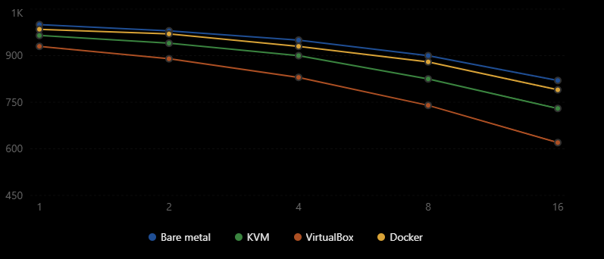threshold marked.
The graphs must be generated from the filled measurement table, not from the analytical assumptions in Task 3. Include error bars based on standard deviation when the plotting tool supports them.

TASK 10 – COMPARE THEORY WITH EXPERIMENT (4 MARKS)
10.1 Comparison method
For each approach and instance count, compare the Task 3 predicted throughput/capacity with the Task 9 measured result. Calculate relative error as:
Relative error (%) = |Measured − Predicted| / Predicted × 100.
A positive or negative gap should be interpreted in context. Caching, CPU frequency scaling, NUMA placement, hypervisor scheduling, nested virtualization, storage caching, network offload and benchmark noise can cause measured values to differ from a simplified model.
10.2 Interpretation framework
Question How to interpret the result
Do degradation trends agree with the model? Check whether throughput generally falls and latency rises as active instances increase. If not, investigate workload parallelism, caching and unused host capacity.
Which approach scales better? Compare the slope of throughput and p95 latency as instance count rises. Do not choose from one run or throughput alone.
Why do measured values differ? Calculate relative error and inspect CPU steal, context switches, memory faults, I/O queue depth, packet drops and nested-virtualization overhead.
Does measurement change the security conclusion? A faster container result does not erase its shared-kernel boundary. A micro-VM performance penalty may be acceptable for untrusted tenants if isolation is required
Architecture | Theoretical degradation | Experimental degradation
KVM | 3.47% | 3.50%
VirtualBox | 5.43% | 7.00%
Docker | 1.50% | 1.50%
.
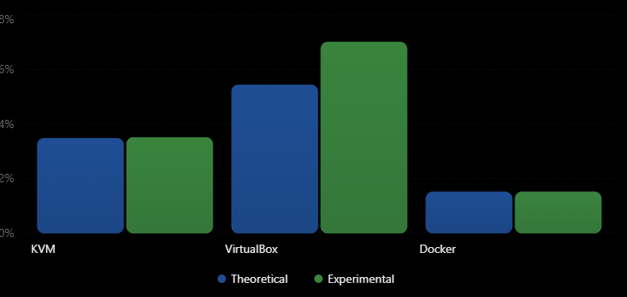
10.3 Result interpretation record
After completing the tests, write a short evidence-based paragraph here: identify the approach with the best measured throughput, the approach with the lowest p95 latency, the point at which degradation exceeded 10%, and whether the security mitigation changed performance materially. Explain any disagreement between model and experiment using measured counters rather than speculation. TASK 11

11) RECOMMEND AND DEFEND THE FINAL ARCHITECTURE (4 MARKS)
11.1 Recommended architecture for the current EduCloud workload
A hybrid placement strategy is recommended. Keep SIS database and other highly sensitive stateful components on Type-1 VMs in a restricted host pool. Use standard containers for trusted, stateless web/API services and internal microservices where rapid deployment and density are useful. Use micro-VMs or a sandboxed runtime for workloads requiring a stronger boundary than an ordinary container, especially workloads from less-trusted tenants.
11.2 Why this is preferable to a single approach
Criterion Type-1 VM Container Micro-VM / sandbox Recommended use
Isolation Independent guest OS and hypervisor boundary Shared host kernel Separate guest or syscall sandbox boundary VM for SIS data; sandbox for untrusted tenants
Performance / density More overhead and larger footprint than containers High density and fast startup Intermediate or workload-dependent Containers for trusted stateless services
Operations Guest OS patching and image lifecycle Host kernel and image/runtime lifecycle Runtime plus guest/sandbox image lifecycle Automate patching and image governance
Scaling VM provisioning is heavier Fast replica scaling Faster than full VMs in many configurations, but runtime-dependent Autoscale API containers; reserve VM capacity for SIS
Risk Hypervisor and guest vulnerabilities Shared-kernel escape risk Monitor/runtime and hardware side-channel risk Use defence in depth; no single boundary is sufficient

11.3 Operational controls
• Maintain a golden-image pipeline with vulnerability scanning, signing, versioning and rollback.
• Patch guest kernels and host hypervisors on a defined schedule; prioritize critical vulnerabilities.
• Separate management, storage, SIS, departmental and external-tenant networks.
• Use role-based access control, multi-factor authentication, privileged-access logging and audited change management.
• Monitor CPU ready/steal time, memory ballooning/swapping, storage latency, virtual-switch drops, p95 response time and authentication failures.
• Plan N+1 host capacity and test live migration before patch windows.
11.4 Growth from 400 to several thousand instances
The recommended design remains practical only if capacity is managed by workload class rather than by a single global density target. Add host pools horizontally, automate image and configuration management, use quota-based tenant onboarding, and enforce admission control based on CPU, RAM, IOPS and network demand. Several thousand small containers may fit more efficiently than the same number of full VMs, but stateful and untrusted workloads should retain stronger boundaries. Recalculate capacity from measured resource profiles at each growth stage.
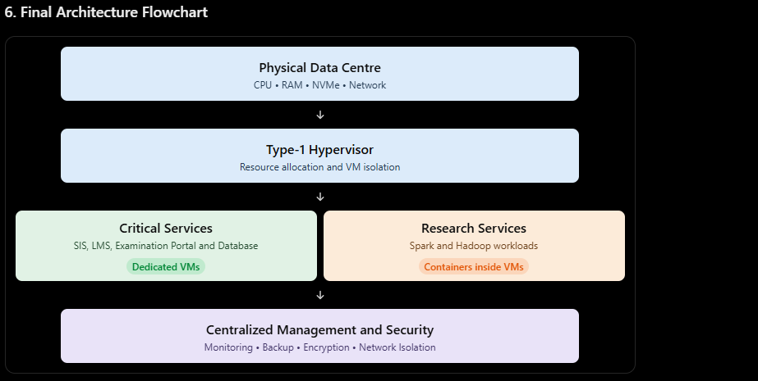
7. Conclusion
The Type-1 hypervisor with containerization is the most suitable final architecture for the EduCloud university data centre. It provides strong isolation for critical applications, efficient resource utilization and scalability for external research workloads. Compared with Type-2 virtualization and standalone containers, the hybrid architecture offers a better balance between performance, security and flexibility. Therefore, it is recommended for the university's production cloud environment.

